**ANGAMALY-683577**



‘**FOCUS ON EXCELLENCE’**

**NETWORKING AND SYSTEM ADMINISTRATION LAB**

…………………………………………………………………..

# LABORATORY RECORD

**Name: ANTONY VARGHESE Branch: MASTER OF COMPUTER APPLICATION**

**Semester: 2 Batch: A Roll No: 31**

# ANGAMALY-683577



‘**FOCUS ON EXCELLENCE’**

**Name : ANTONY VARGHESE**

**Branch : MASTER OF COMPUTER APPLICATION**

**Semester : 2 Roll No: 31**

**University Exam.RegNo: FITMCA20-2031**

**CERTIFICATE**

*This is to certify that this is a Bonafide record of the Practical work done and submitted to Kerala Technological University in partial fulfillment for the award of the Master Of Computer Applications is a record of the original research work done by* **ANTONY VARGHESE** *in the* ***NETWORKING AND SYSTEM ADMINISTRATION LAB*** *Laboratory of the Federal Institute of Science and Technology during the academic year 2020-2021.*

Signature of Staff in Charge Signature of H.O.D

Name: Name:

Date:

### Date of University practical examination ………………………

Signature of Signature of

Internal Examiner External Examiner

# CONTENT

|  |  |  |  |  |
| --- | --- | --- | --- | --- |
| **SI**  **No:** | **Date :** | **Name of Experiment:** | **Page No:** | **Signature of Staff –In – Charge:** |
| 1 | 27-11-20 | COMPONENT IDENTIFICATION | 1 |  |
| 2 | 27-11-20 | LINUX COMMANDS | 24 |  |
| 3 | 4-12-20 | SHELL SCRIPT | 32 |  |
| 4 | 17-12-20 | FILE SYSTEM | 45 |  |
| 5 | 31-12-20 | LAMP STOCK SERVER | 51 |  |
| 6 | 14-01-21 | LARAVEL SERVER | 55 |  |
| 7 | 15-01-21 | NETWORKING COMMANDS | 67 |  |
| 8 | 21-01-21 | WIRE SHARK | 70 |  |
| 9 | 21-01-21 | VIRTUAL BOX | 74 |  |
| 10 | 21-01-21 | INTRODUCTION TO VIRTUAL MACHINES | 79 |  |

**EXPERIMENT- 1**

## BASIC INTRODUCTORY CONCEPT OF COMPUTER HARDWARE

### What is Computer?

A computer is a programmable electronic device that accepts raw data as input and processes it with a set of instructions (a program) to produce the result as output. It renders output just after performing mathematical and logical operations and can save the output for future use. It can process numerical as well as non-numerical calculations.

### History of Computers

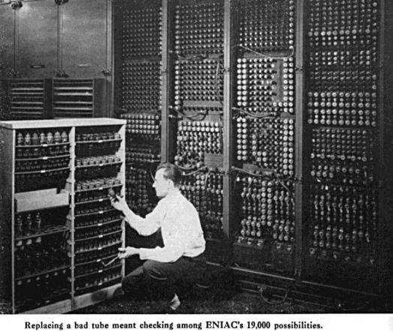

Since the evolution of humans, devices have been used for calculations for thousands of years. One of the earliest and well-known devices was an abacus. Then in 1822, the father of computers, **Charles Babbage** began developing the first mechanical computer.

### Computer Hardware

Computer hardware includes the physical parts of a computer, such as the case, central processing unit (CPU), monitor, mouse, keyboard, computer data storage, graphics card, sound card, speakers and motherboard. Hardware is typically directed by the software to execute any command or [instruction.](https://en.wikipedia.org/wiki/Instruction_(computing)) A combination of hardware and software forms a usable [computing](https://en.wikipedia.org/wiki/Computing) system, although [other systems](https://en.wikipedia.org/wiki/Digital_electronics) exist with only hardware.

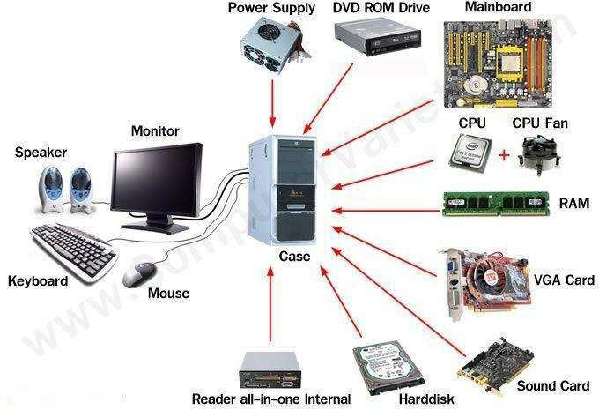

The following are the basic components that will be detailed :-

1. Motherboard
2. RAM Modules
3. Daughter cards
4. Bus slots
5. SMPS
6. Internal Storage Devices
7. Interfacing Ports

## MOTHERBOARD

A motherboard (also called mainboard, main circuit board, system board, baseboard, planar board ,logic board or mobo) is the main printed circuit board (PCB) in general- purpose computers and other expandable systems. It holds and allows communication between many of the crucial electronic components of a system, such as the central processing unit (CPU) and memory, and provides connectors for other peripherals. Unlike a backplane, a motherboard usually contains significant sub-systems, such as the central processor, the chipset's input/output and memory controllers, interface connectors, and other components integrated for general use.

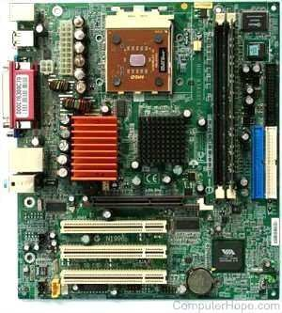

Motherboard means specifically a PCB with expansion capabilities. As the name suggests, this board is often referred to as the "mother" of all components attached to it, which often include peripherals, interface cards, and daughter cards: soundcards, video cards, network cards, host bus adapters, TV tuner cards, IEEE 1394 cards; and a variety of other custom components.

## FEATURES OF MOTHERBOARD

* Motherboard varies greatly in supporting various types of components.
* Motherboard supports a single type of CPU and few types of memories.
* Video cards, hard disks, sound cards have to be compatible with the motherboard to function properly.
* Motherboards, cases, and power supplies must be compatible to work properly together.

## TYPES OF MOTHERBOARD

### AT Motherboard

These motherboards have bigger physical dimensions of hundreds of millimeters and hence they are not the right fit for the mini desktop category of computers.

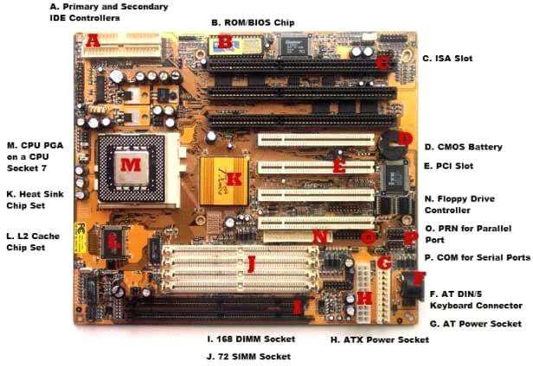

### ATX Motherboards

ATX denotes Advanced technology extended, It was developed by Intel during the 1990s and it was an improved version over an earlier version of AT motherboard. It is smaller in size when compared to AT and it provides interchangeability of the connected components.

### BTX Motherboard

BTX denotes Balanced Technology Extended, intended to manage demands of new technologies in terms of more power requirements hence generation of more heat.

### Pico BTX Motherboard

These boards are smaller in size and hence the word Pico. Two expansion slots are supported in spite of being sharing the top half of BTX. Half-height or riser cards are its unique features and it supports the demands of digital applications.

### Mini ITX Motherboard

It’s a miniature version of motherboard. Designed in the early 2000s and its dimension is 17 x 17 cm. Mainly used in small form factor (SFF) computer due to its lower power consumption and faster cooling ability.

## MAIN COMPONENTS OF MOTHERBOARD

* 1. **FLOPPY DISC CONTROLLER**

A floppy disk controller (FDC) is an electronic chip controller used as an interface between a computer and a floppy disk drive. Modern computers have this chip embedded in the motherboard, whereas they were a separate component when they were originally introduced.

A floppy disk controller (FDC) is a specially designed chip that controls the reading and writing functionality of a floppy drive. An FDC can support up to four floppy disk drives at a time. The controller is connected to the system bus of the CPU and appears as a set of I/O ports to the computer. It is usually also linked to a serial bus of the direct memory access (DMA) controller. In an x86 computer, the floppy disk controller uses IRQ6, whereas interrupt schemes are used on other systems. Data transmission is often done by FDC while in DMA mode.

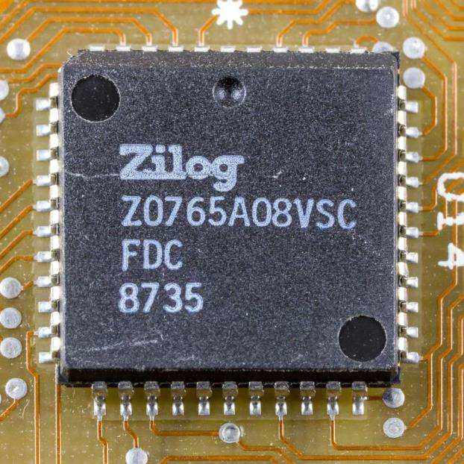

Floppy disk controller functions (FDC)

* Translate data bits into FM, MFM, M²FM, or GCR format to be able to record them
* Interpret and execute commands such as seek, read, write, format, etc.
* Error detection with check sums generation and verification, like CRC
* Synchronize data with phase-locked loop(PLL)

### Serial Ports

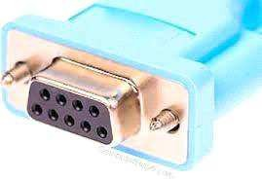

Serial Ports provide an interface to connect serial lines to prepare a serial communication. Serial ports are typically used in modem, mouse, security cameras etc. A Serial port uses DB-9 connector, a 9 pin D-Shaped Connector which connects to the transmission line. A serial port provides a serial communication using one line and thus have no dependency on other wire's speed and its length can be extended as per the need.

### Parallel Ports

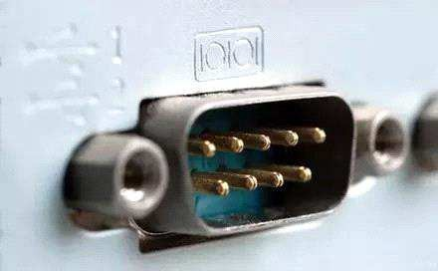

Parallel ports provide an interface to connect multiple lines to prepare a parallel communication to send large data at a time. Parallel ports are used in connecting printers, hard-drives, CD-drives etc. All lines speed should be same to avoid error and cross-talk issues. To avoid such issues, the wires are kept small in length. A parallel port uses D-25 connector, a 25 pin D- Shaped connector which connects to the transmission wires.

### The Expansion Buses

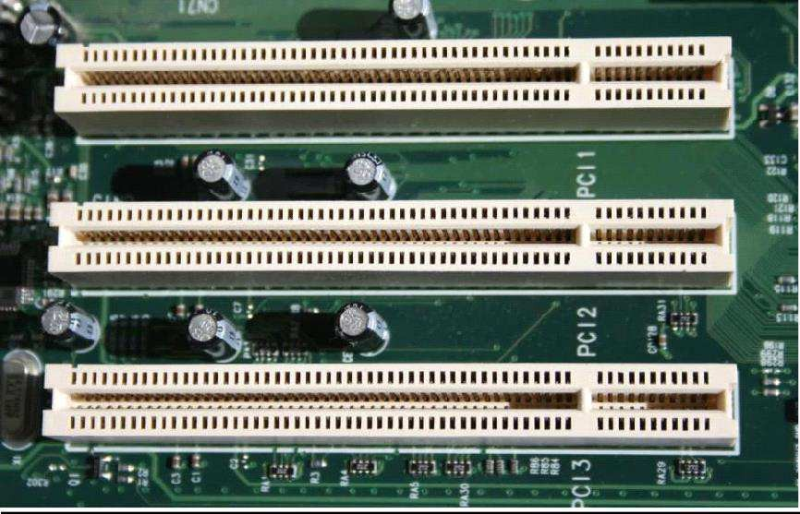

An expansion bus is an input/output pathway from the CPU to peripheral devices and it is typically made up of a series of slots on the motherboard. Expansion boards(cards) plug into the bus. PCI is the most common expansion bus in a PC and other hardware platforms. PCI stands for Peripheral Component Interface; PCI slot allows you to insert expansion cards into your computer. Buses carry signals such as data, memory addresses, power, and control signals from component to component. Other types of buses include ISA and EISA. Expansion buses enhance the PCs capabilities by allowing users to add missing features in their computers by slotting adapter cards into expansion slots.

### The Computer Chip-sets

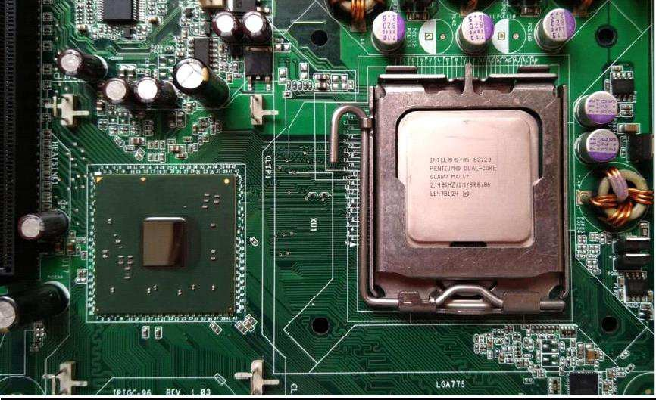

A chipset is a group of small circuits that coordinate the flow of data to and from a PC's key components. These key components include the CPU itself, the main memory, the secondary cache, and any devices situated on the buses. A chip set also controls data flow to and from hard disks and other devices connected to the IDE channels.

A computer has got two main chipsets:

The North Bridge (also called the memory controller) is in charge of controlling transfers between the processor and the RAM, which is why it is located physically near the processor. It is sometimes called the GMCH, for Graphic and Memory Controller Hub. The South Bridge (also called the input/output controller or expansion controller) handles communications between slower peripheral devices. It is also called the ICH (I/O Controller Hub). The term "bridge" is generally used to designate a component which connects two buses. Chipset manufacturers include SIS, VIA, ALI, and OPTI.

## RANDOM ACCESS MEMORY

### Introduction

RAM, which stands for Random Access Memory, is a hardware device generally located on the motherboard of a computer and acts as an internal memory of the CPU. It allows CPU store data, program, and program results when you switch on the computer. It is the read and write memory of a computer, which means the information can be written to it as well as read from it.

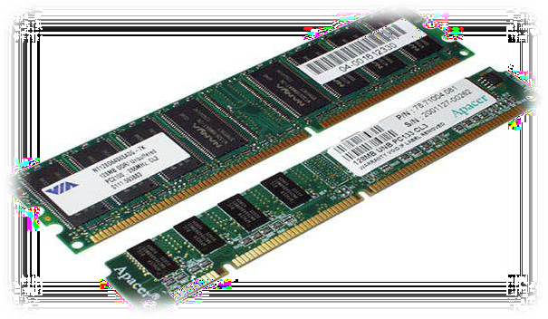

RAM comes in the form of a chip that is individually mounted on the motherboard or in the form of several chips on a small board connected to the motherboard. It is the main memory of a computer. It is faster to write to and read from as compared to other memories such as a hard disk drive (HDD), solid-state drive (SSD), optical drive, etc.

A computer's performance mainly depends on the size or storage capacity of the RAM. If it does not have sufficient RAM (random access memory) to run the OS and software

programs, it will result in slower performance. So, the more RAM a computer has, the faster it will work. Information stored in RAM is accessed randomly, not in a sequence as on a CD or hard drive. So, its access time is much faster.

## CHARACTERISTICS OF RAM

* 1. **SDRAM AND DDR**

Memory modules are labelled with either SDRAM (Synchronous Dynamic Random- Access Memory) or DDR (Double Data Rate). DDR RAM, as the "double data rate" name suggests, offers much faster speeds than SDRAM. Each generation of DDR, such as DDR2 and DDR3, offers performance improvements over the one preceding it.

* 1. **SPEED**

The two numbers often quoted first on memory module specifications -- for example, "DDRxxx/PCxxxx" -- indicate the maximum clock speed and maximum transfer rate the device can operate at -- and the higher the better. The stated clock speed is actually double the real figure, so a stick of RAM labelled DDR3-1333 PC3200 offers a clock speed of 666 MHz and a transfer rate of 3,200 MB/s.

* 1. **PINS**

Essentially, the number of pins a memory module has indicates the number of connections it has to the motherboard -- and thus which motherboards it's compatible with. More pins mean more data can be transferred at once, for faster operation overall, though performance is based on a variety of different factors, including CPU speed and the motherboard configuration.

* 1. **VOLTS**

The voltage rating associated with a memory module -- for example, 2.5 V -- indicates how much power it draws from the motherboard in order to operate properly. RAM sticks that can work at lower voltages use up less power and give off less heat, and are therefore more suitable for smaller systems such as laptops.

* 1. **CAS LATENCY**

CAS (Column Address Strobe) Latency, sometimes abbreviated to just "CL," indicates the time it takes for a memory module to return data to the CPU. A lower CAS Latency indicates RAM that performs faster.

* 1. **TIMING**

Memory modules feature other timings besides CAS Latency, usually listed as a series of numbers after the other specifications. In order after CAS Latency, they are RAS (Row Address Strobe) to CAS delay, RAS Precharge, Active to Precharge delay and, optionally, command rate. These timings are only really of interest to advanced technical users, as the impact they have on performance is very small.

* 1. **REDUNDANCY**

The redundancy built into a memory module indicates its ability to recover from errors and to alert the operating system to a problem, rather than just allowing it to crash and lose your data. More expensive and critical server memory uses Error Checking and Correcting Redundancy, or ECC, in order to detect and correct errors wherever possible.

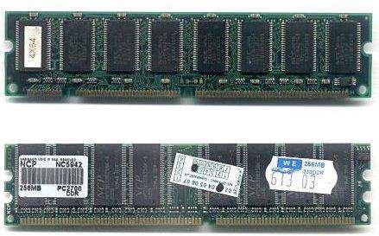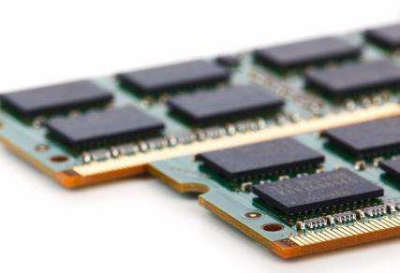

### Different Types of RAM

RAM(Random Access Memory) is a part of computer’s Main Memory which is directly accessible by CPU. RAM is used to Read and Write data into it which is accessed by CPU randomly. RAM is volatile in nature, it means if the power goes off, the stored information is lost. RAM is used to store the data that is currently processed by the CPU. Most of the programs and data that are modifiable are stored in RAM.

Integrated RAM chips are available in two form:

1. SRAM(Static RAM)
2. DRAM(Dynamic RAM)

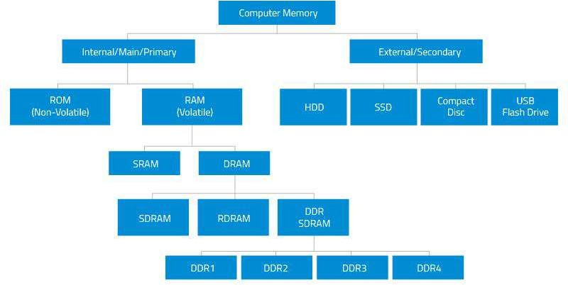

* 1. **SRAM**

The SRAM memories consist of circuits capable of retaining the stored information as long as the power is applied. That means this type of memory requires constant power. SRAM memories are used to build Cache Memory.

* 1. **DRAM**

DRAM stores the binary information in the form of electric charges that applied to capacitors. The stored information on the capacitors tend to lose over a period of time and thus the capacitors must be periodically recharged to retain their usage. The main memory is generally made up of DRAM chips.

### Functions

**3.1. Reading Files**

Hard drives can store vast numbers of files, but compared to other computer components, drives run very slowly. Accessing hard drive files -- especially when those files are scattered across the drive due to fragmentation -- requires the drive to move its mechanical read/write head back and forth and to wait for the spinning platters to spin into the correct position. Even though drives spin at thousands of rotations per minute,

this process causes a noticeable delay when reading files. To lessen the slowdown, computers store files in RAM after the files are first read from the drive. RAM has no moving parts, so the files can load very quickly during subsequent uses.

### Temporary Storage

In addition to storing files read from the hard drive, RAM also stores data that programs are actively using but that doesn't need to be saved permanently. By keeping this data in RAM, programs can work with it quickly, improving speed and responsiveness.

### RAM Size

If RAM works so much faster than the hard drive, why not load all of the computer's data into RAM? One major reason: computers have far less RAM than drive space. As of publication, hard drive sizes range from a few hundred gigabytes in laptops to 10TB in high-end enterprise systems. Most home computers have between 1 and 4TB of drive space.

## DAUGHTER CARD

Referred to as a piggyback board and **daughter card**, a daughterboard is an expansion board that connects directly to the motherboard and gives added functionality.

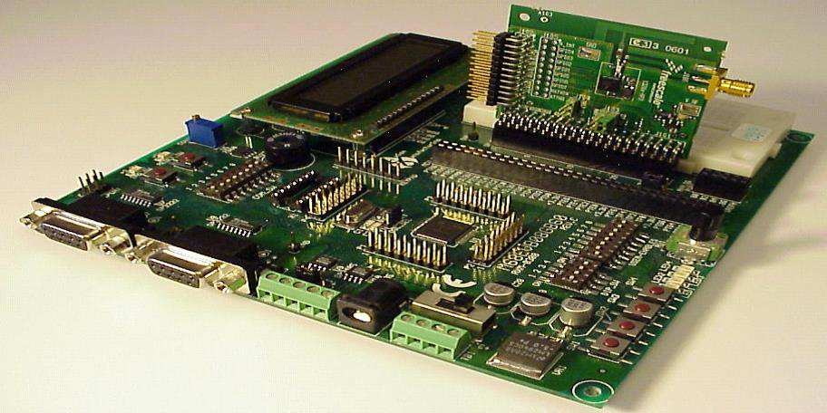

To disable a daughter board, the user must physically remove it from the motherboard Daughter boards do not provide new functions to the circuit like an expansion but they extend the circuitry of the circuit in which they are plugged into

### Functionalities of daughter board:

* It is known as the piggyback board, riser card, daughter card etcetera.
* A daughter board is smaller than a motherboard and may have some slots like the motherboard.
* A daughter board is a printed circuit board which is connected to the motherboard or expansion card.
* Unlike expansion card, daughter boards are directly connected to the motherboard by soldering.
* Daughter boards do not provide new functions to the circuit like an expansion but they extend the circuitry of the circuit in which they are plugged into.
* Daughter boards are released by the vendors as an update of motherboard or expansion card.

### List of daughter cards

* Video Card: This is also referred to as the graphics adapter, display adapter or video adapter.
* Sound Card: To handle sound, to insert a microphone or connect a speaker this sound card is used.
* Network Interface Card: This is also referred as NIC. The computer can be connected to a network only with the use of this network interface card.
* Ethernet Card: Ethernet card is used to connect computers to computers. A cable is used to connect the Ethernet cards in each computer to make a network.

## SWITCHED- MODE POWER SUPPLY

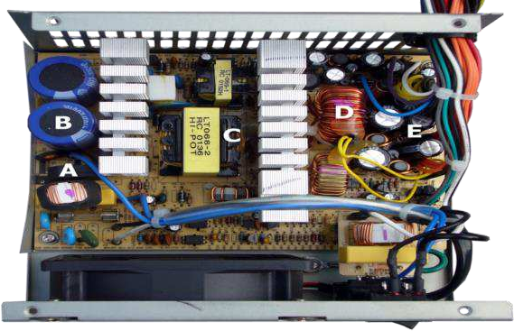Switched-mode power supply Introduction A switched-mode power supply (switching- mode power supply, switch-mode power supply, switched power supply, SMPS, or switcher) is an electronic power supply that incorporates a switching regulator to convert electrical power efficiently. Its function is to convert a level of voltage to the voltage or current required by the client through different forms of architecture.

## WORKING

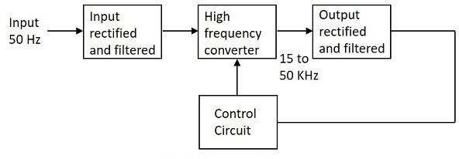

The working of SMPS is simply understood by knowing that the transistor used in LPS is used to control the voltage drop while the transistor in SMPS is used as a controlled switch. The AC input supply signal 50 Hz is given directly to the rectifier and filter circuit combination without using any transformer. A fast switching device such as a Power transistor is employed in this section, which switches ON and OFF according to the variations and this output is given to the primary of the transformer. This is a regulated output voltage which is then given to the control circuit, which is a feedback circuit

## INTERNAL STORAGE DEVICES

A storage device is any type of computing hardware that is used for storing, porting or extracting data files and objects. Storage devices can hold and store information both temporarily and permanently. They may be internal or external to a computer.

Some storage devices are classed as 'internal' which means they are inside the computer case. At the most basic level, internal storage is needed to hold the operating system so that the computer is able to access the input and output devices. It will also be used to store the applications software that you use and more than likely, the original copies of your data files.

Internal storage allows the data and applications to be loaded very rapidly into memory, ready for use. The data can be accessed much faster than data which is stored on an external storage device. This is because internal storage devices are connected directly to the motherboard and its data bus whereas external devices are connected through a hardware interface such as USB, which means they are considerably slower to access.

The main disadvantage of internal storage is that when the hard disk fails (and it will), all the data and applications may be lost. This can be avoided to some extent by using more than one hard disk within the machine. Each hard disk has a copy of all the data, so if one fails the other can carry on. This is called a RAID array. An alternative is to use external drives for backup

### Examples of Internal storage devices

* + Hard Disk
  + SSD
  + RAM

## HARD DISK

A **hard disk drive** (sometimes abbreviated as a **hard drive**, **HD**, or **HDD**) is a [non-](https://www.computerhope.com/jargon/n/nonvolat.htm) [volatile](https://www.computerhope.com/jargon/n/nonvolat.htm) data [storage device.](https://www.computerhope.com/jargon/s/stordevi.htm) It is usually installed internally in a computer, attached directly to the disk controller of the computer's [motherboard](https://www.computerhope.com/jargon/m/mothboar.htm). It contains one or more [platters](https://www.computerhope.com/jargon/p/platter.htm), housed inside of an air-sealed casing. Data is written to the platters using a magnetic head, which moves rapidly over them as they spin.

[Internal](https://www.computerhope.com/jargon/i/internal.htm) hard disks reside in a [drive bay,](https://www.computerhope.com/jargon/b/bay.htm) connected to the motherboard using an [ATA,](https://www.computerhope.com/jargon/a/ata.htm) [SCSI](https://www.computerhope.com/jargon/s/scsi.htm), or [SATA](https://www.computerhope.com/jargon/s/sata.htm) cable. They are powered by a connection to the computer's [PSU](https://www.computerhope.com/jargon/p/power-supply.htm) (power supply unit).

Hard disk, Magnetic storage medium for a [microcomputer](https://www.britannica.com/technology/microcomputer). Hard disks are flat, circular plates made of aluminum or glass and coated with a magnetic material. Hard disks for [personal computers](https://www.britannica.com/technology/personal-computer) can store up to several gigabytes (billions of bytes) of information. Data are stored on their surfaces in concentric tracks. A small electromagnet, called a magnetic head, writes a [binary digit](https://www.britannica.com/technology/bit-communications) (1 or 0) by magnetizing tiny spots on the spinning disk in different directions and reads digits by detecting the magnetization direction of the spots. A computer’s hard drive is a device consisting of several hard disks, read/write heads, a drive motor to spin the disks, and a small amount of circuitry, all sealed in a metal case to protect the disks from dust. In addition to referring to the disks themselves, the term hard disk is also used to refer to the whole hard drive.

Computers rely on hard disk drives (HDDs) to store data permanently. They are storage devices used to save and retrieve digital information that will be required for future reference.

Hard drives are non-volatile, meaning that they retain data even when they do not have power. The information stored remains safe and intact unless the hard drive is destroyed or interfered with. The information is stored or retrieved in a random-access manner as opposed to sequential access. This implies that blocks of data can be accessed at any time they are required without going through other data blocks.

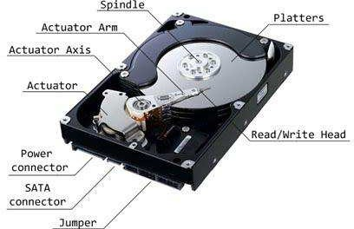

## SOLID STATE DRIVE

A solid-state drive (SSD) is a [solid-state storage](https://en.wikipedia.org/wiki/Solid-state_storage) device that uses [integrated](https://en.wikipedia.org/wiki/Integrated_circuit) [circuit](https://en.wikipedia.org/wiki/Integrated_circuit) assemblies to store data [persistently](https://en.wikipedia.org/wiki/Persistence_(computer_science)) , typically using [flash memory,](https://en.wikipedia.org/wiki/Flash_memory) and functioning as [secondary storage](https://en.wikipedia.org/wiki/Secondary_storage) in the [hierarchy of computer storage](https://en.wikipedia.org/wiki/Computer_data_storage#Hierarchy_of_storage). It is also sometimes called a **solid-state device** or a **solid-state disk**, even though SSDs lack the physical spinning [disks](https://en.wikipedia.org/wiki/Hard_disk_drive_platter) and movable [read–write heads](https://en.wikipedia.org/wiki/Disk_read-and-write_head) used in [hard disk](https://en.wikipedia.org/wiki/Hard_disk_drive) [drives](https://en.wikipedia.org/wiki/Hard_disk_drive) (HDDs) and [floppy disks.](https://en.wikipedia.org/wiki/Floppy_disk)

Compared with electromechanical drives, SSDs are typically more resistant to physical shock, run silently, and have quicker [access time](https://en.wikipedia.org/wiki/Access_time) and lower [latency.](https://en.wikipedia.org/wiki/Latency_(engineering)) SSDs store data in [semiconductor](https://en.wikipedia.org/wiki/Semiconductor) cells. SSDs have a limited number of writes, and slow as they reach storage capacity.

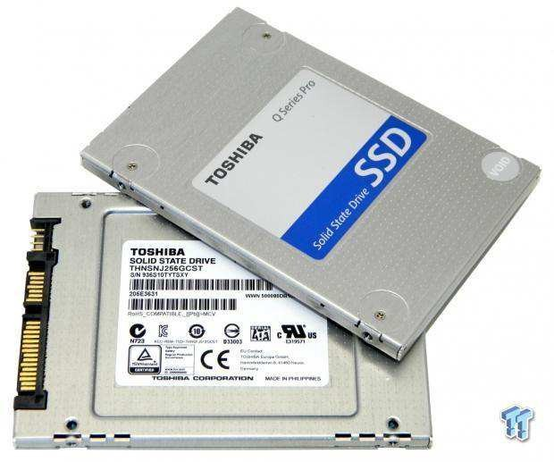

## RAM

RAM (Random Access Memory) is the internal memory of the CPU for storing data, program, and program result. It is a read/write memory which stores data until the machine is working. As soon as the machine is switched off, data is erased.

RAM is volatile, i.e. data stored in it is lost when we switch off the computer or if there is a power failure. RAM is small, both in terms of its physical size and in the amount of data it can hold.

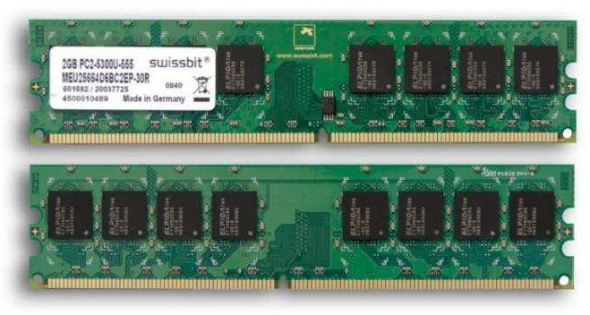

RAM is of two types −

* + - Static RAM (SRAM)
    - Dynamic RAM (DRAM)

### Static RAM (SRAM)

The word **static** indicates that the memory retains its contents as long as power is being supplied. However, data is lost when the power gets down due to volatile nature. SRAM chips use a matrix of 6-transistors and no capacitors. Transistors do not require power to prevent leakage, so SRAM need not be refreshed on a regular basis.

### Dynamic RAM (DRAM)

DRAM, unlike SRAM, must be continually **refreshed** in order to maintain the data. This is done by placing the memory on a refresh circuit that rewrites the data several hundred times per second. DRAM is used for most system memory as it is cheap and small

## SOME OTHER STORAGE DEVICES

* + - Magnetic Storage Device
    - Optical Storage Device
    - Flash Memory Device
    - Online and Cloud
    - Paper Storage

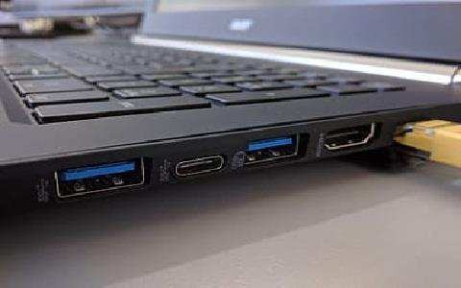

## . COMPUTER PORTS

**WHAT IS MEANT BY A PORT?**

A port in a computer network is a communication endpoint whereas, in an operating system, it is a logical construct, recognizes precise method otherwise a network service type. These endpoints recognize the combination of every protocol and its address through 16-bit unsigned numbers, called the port number. The protocols that use port numbers are the TCP (Transmission Control Protocol) and UDP (User Datagram Protocol). The port number in every computer networking uses an IP address of the type of protocol & the host

### What is Port in Computer/Computer Port?

A computer port or a communication port is a connection point used as an interface between the computer & the peripherals like keyboard, mouse, printer, display unit, monitor, flash drive and speaker. The computer port transmits the data from any peripheral to the computer. In general, the communication ports are available in two type like Serial Ports as well as Parallel Ports.

### Characteristics of Computer Ports

The characteristics of the computer port include the following.

* It is an interface between external devices as well as a computer.
* Ports on the motherboard can be connected using an external device cable by plugging in.
* The external devices which are connected through via ports are the keyboard, mouse, microphone, monitor, speakers, etc.

### Types of Computer Ports

There are different types of ports available in a computer network. Some of them are:

* PS/02
* Serial Port
* Parallel Port
* Ethernet
* VGA Port
* USB Port
* DVI Port
* HDMI Port
* Display Port
  1. **PS/2 PORTS:** PS/2 is a type of [port](https://techterms.com/definition/port) used by older computers for connecting [input](https://techterms.com/definition/inputdevice) [devices](https://techterms.com/definition/inputdevice) such as [keyboards](https://techterms.com/definition/keyboard) and [mice.](https://techterms.com/definition/mouse) The port was introduced with IBM's Personal System/2 computer in 1987 (which was abbreviated"PS/2").The PS/2 port has six pins and is roughly circular in shape

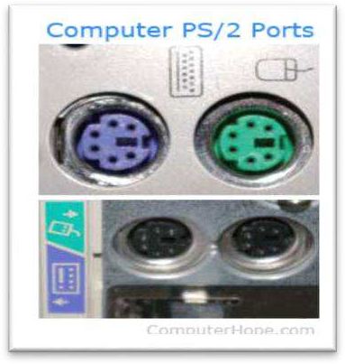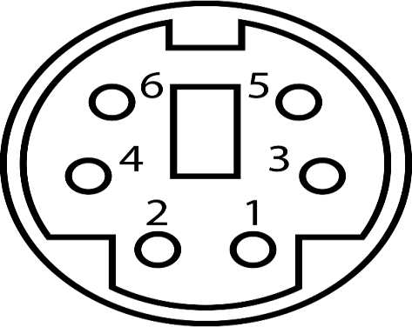

* 1. **SERIAL PORT:** A serial port is an interface that allows a PC to transmit or receive data one bit at a time. It is one of the oldest types of interfaces commonly used to connect printers and external modems to a PC. Compared to a parallel port, the data transfer rate of a serial port is slower. Normally, a serial port is a male port, while a

parallel port is a female port. The serial port standard is RS-232. This standard is used for transmitting serial communication between devices,

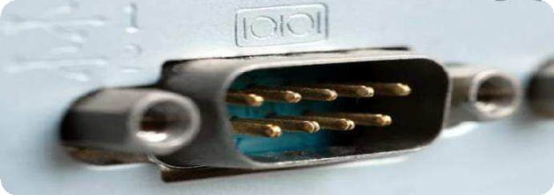

* 1. **PARALLEL PORT: Parallel port** is a type of interface found on computers (personal and otherwise) for connecting peripherals. Parallel ports send multiple bits of data at once (parallel communication), as opposed to serial communication, in which bits are sent one at a time. Parallel port is an interface between computer and peripheral devices like printers with parallel communication

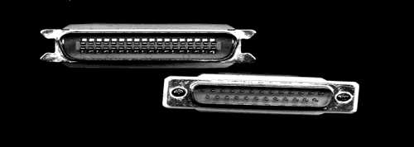

* 1. **ETHERNET:** A Ethernet port is a jack or socket on a computer that allows the use of an Ethernet connector. These ports are essential in allowing the creation of local area networks (LANs). An Ethernet port is usually found on networking devices, including computers, routers, video game consoles, modems, and televisions. Ethernet is a communication system that allows multiple local devices to share information and work together.

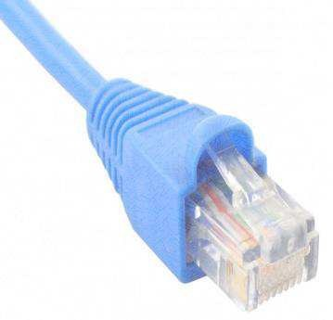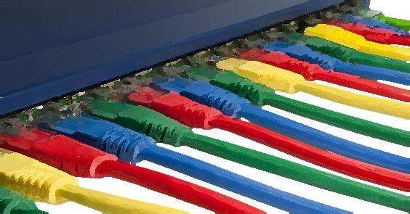

* 1. **VGA PORT:** Abbreviated VGA, Video Graphics Array is a standard type of connection for video devices such as monitors and projectors. Generally, VGA refers to the types of cables, ports, and connectors used to connect monitors to video cards.

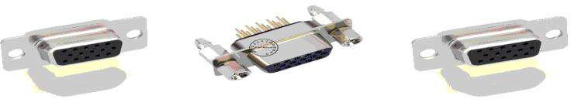 .

* 1. **USB PORT:** A **USB port** is a standard cable connection interface for personal computers and consumer electronics devices. [USB stands for Universal Serial Bus](https://www.lifewire.com/universal-serial-bus-usb-2626039), USB ports allow USB devices to be connected to each other with and transfer digital data over USB cables

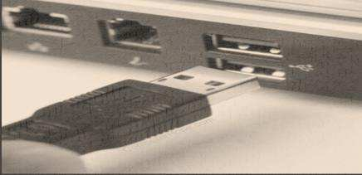

* 1. **HDMI PORT:** Full form of HDMI is **High-Definition Multimedia Interface.**

HDMI is a [proprietary](https://en.wikipedia.org/wiki/Proprietary_hardware) audio/video [interface](https://en.wikipedia.org/wiki/Interface_(computing)) for transmitting [uncompressed video](https://en.wikipedia.org/wiki/Uncompressed_video) data and compressed or uncompressed [digital audio](https://en.wikipedia.org/wiki/Digital_audio) data from an HDMI-compliant source device, such as a [display controller](https://en.wikipedia.org/wiki/Display_controller), to a compatible [computer monitor](https://en.wikipedia.org/wiki/Visual_display_unit), [video](https://en.wikipedia.org/wiki/Video_projector) [projector](https://en.wikipedia.org/wiki/Video_projector), [digital television,](https://en.wikipedia.org/wiki/Digital_television) or [digital audio](https://en.wikipedia.org/wiki/Digital_audio) device..

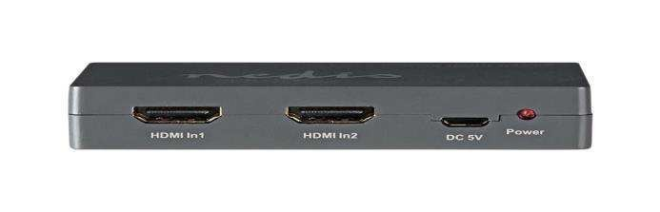

* 1. **DISPLAY PORT**: DisplayPort is a digital display interface developed by a consortium of PC and chip manufacturers and standardized by the Video Electronics Standards Association. Display Port is a digital display interface with optional multiple

channel audio and other forms of data. Display Port is developed with an aim of replacing VGA and DVI ports as the main interface between a computer and monitor.

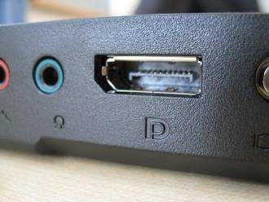

# EXPERIMENT- 2 LINUX COMMANDS

**Q1.** Create the directories and files as given in the above directory structure. Directories are mentioned as (d). Files should be filled with necessary text data.

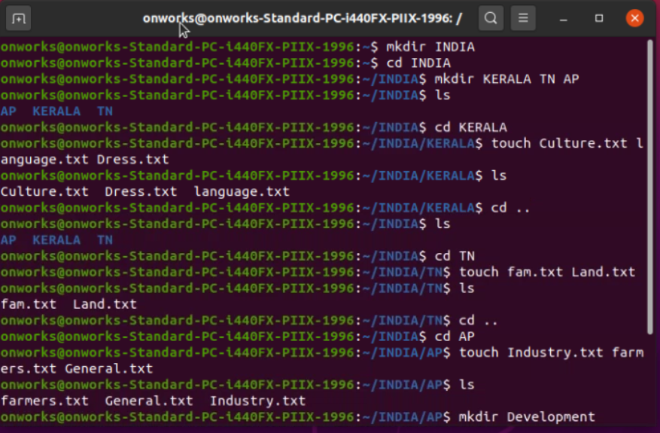

**Q2.** List your present working directory.

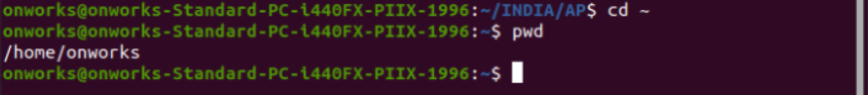

**Q3.** Move to the root directory.

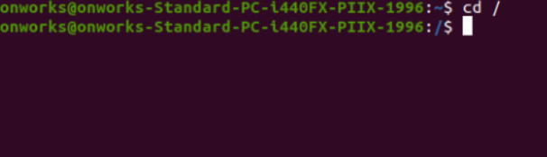

**Q4.** Copy the file ‘Culture’ to the folder AP.

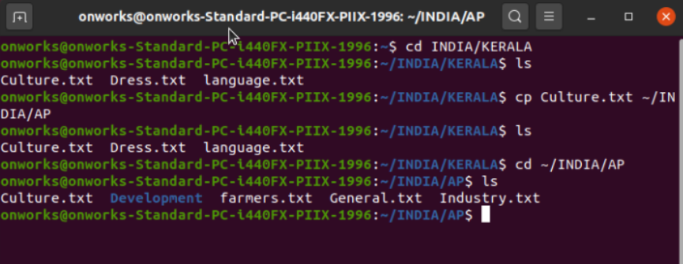

**Q5.** Display the content of the file ‘general’.

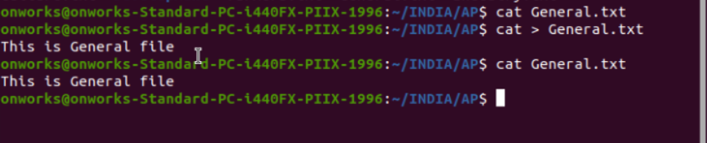

**Q6.** Move the file ‘language’ to the directory AP/Development.

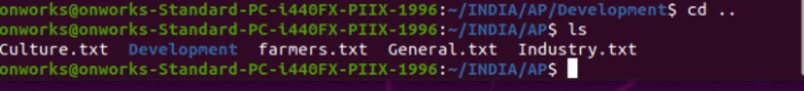

**Q7.** List all the files in the folder AP.



**Q8.** List first 10 lines of the file ‘Dress’.

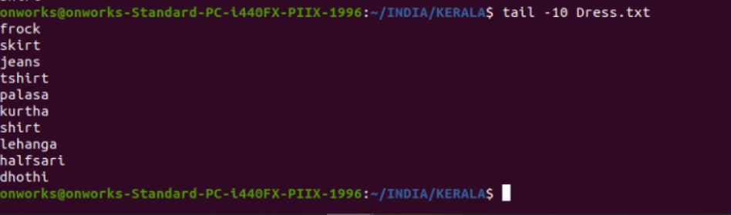

**Q9.** List the last 10 lines of the file ‘Dress’.



**Q10.** List all the files in AP in long listing format.

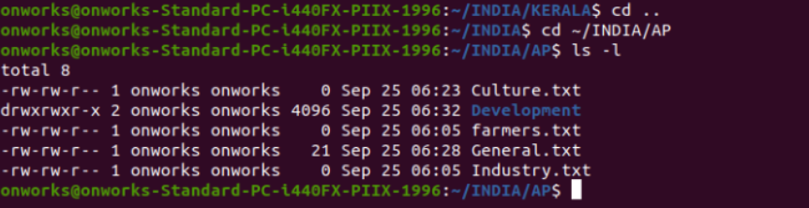

**Q11.** List the files in AP which begin with the character ‘f’.

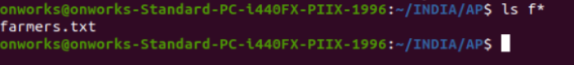

**Q12.** List the files page by page.

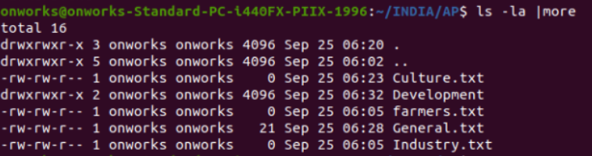

**Q13.** Remove the file ‘general’.



**Q14.** Change the permission of the file ‘Culture’ as only read permission to all.



**Q15.** List the lines of the file which contains a string ‘Saree’.

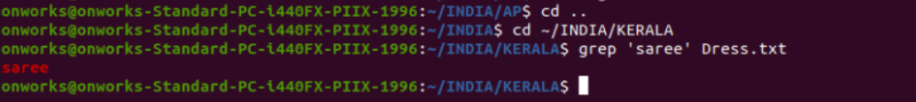

**Q16.** Use man command to get the syntax of wc command.



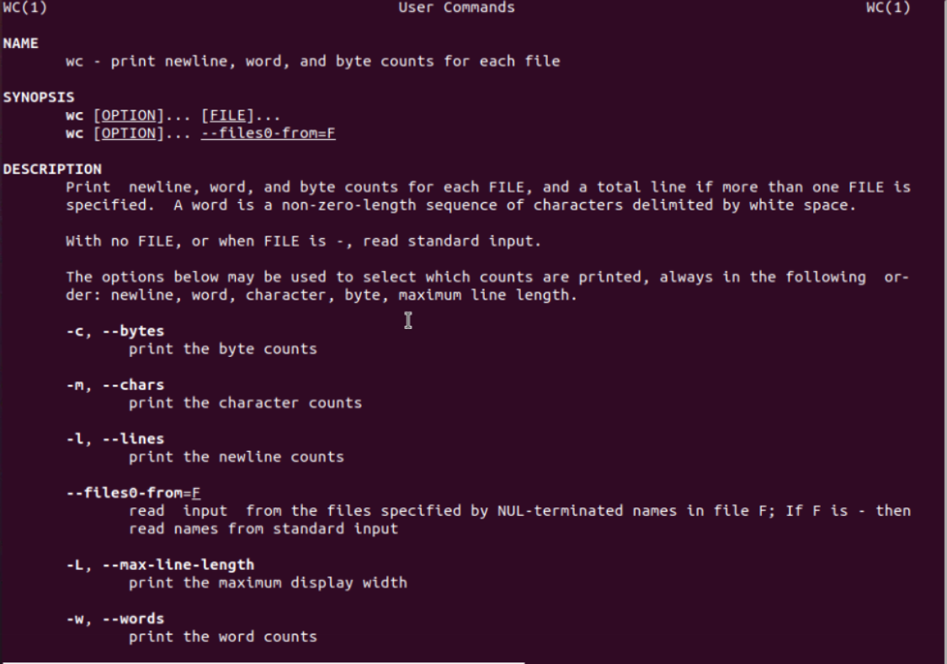

**Q17.** Count the number of characters, words, lines in the directory listing.



**Q18.** Put a listing of the files in your directory into a file called filelist.

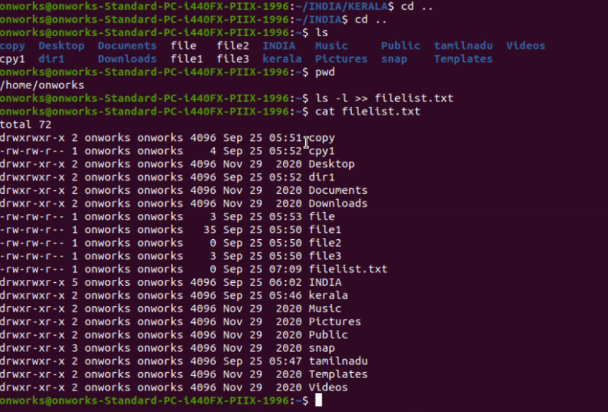

**Q19.** List the status of all process runningin your system

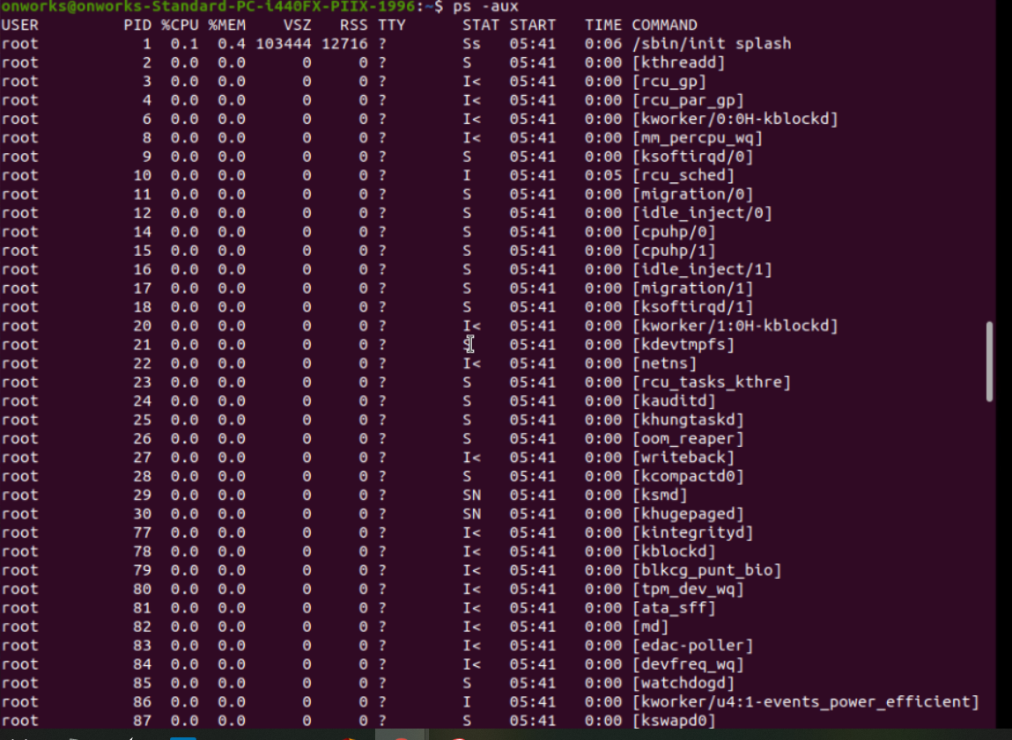

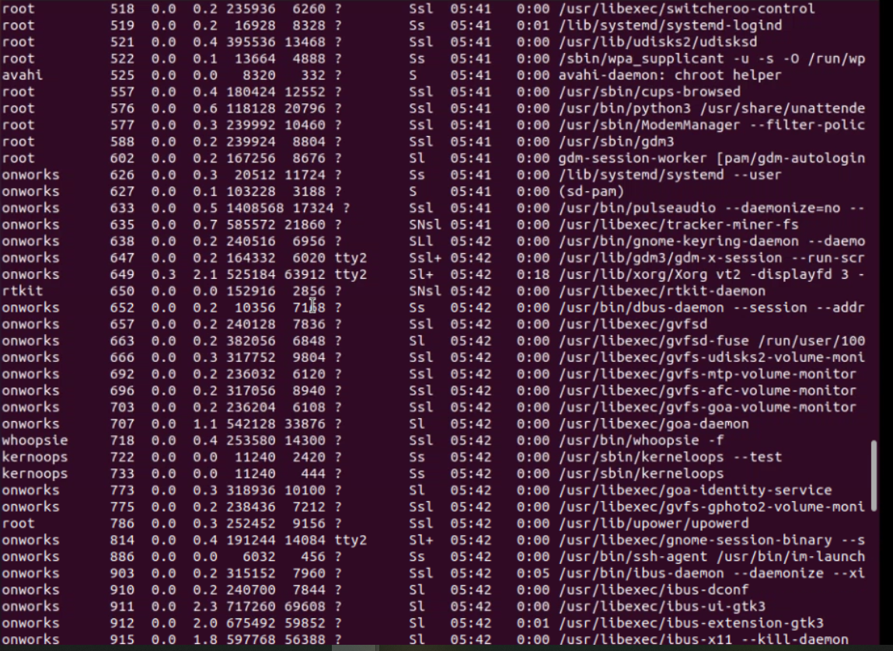

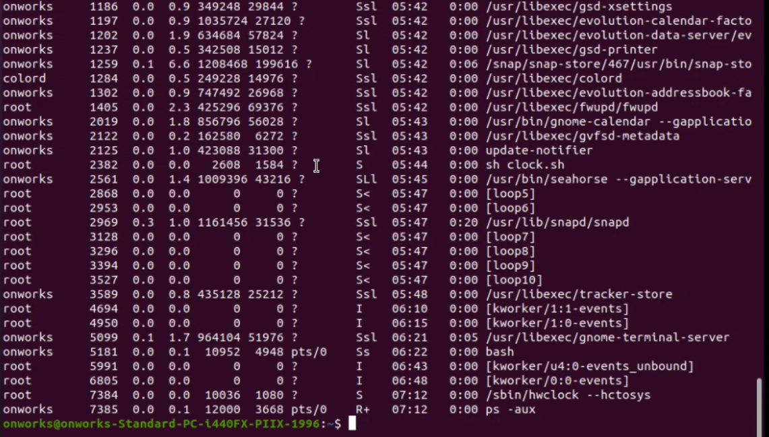

**Q20.** List the disk partitions in your harddisk.

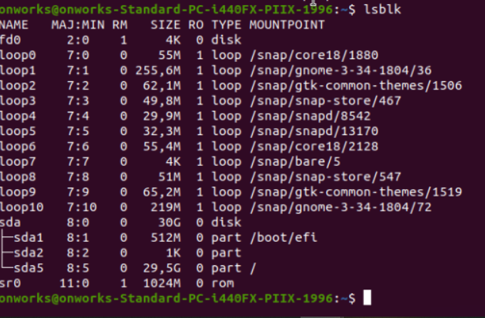

**Q21.** Redirect the output of the top program to a file called ‘errors’

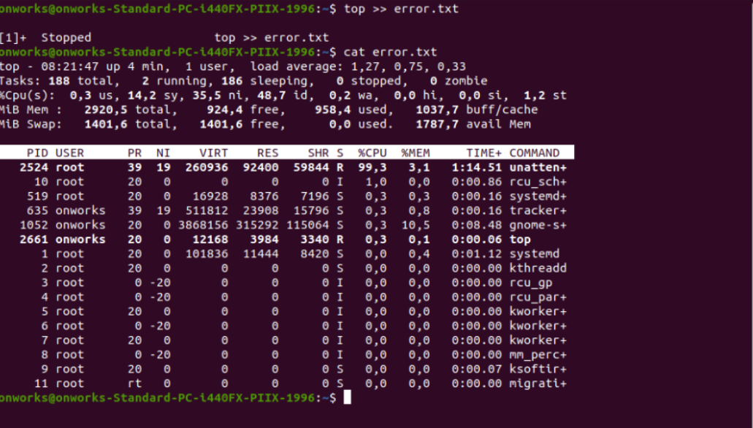

# EXPERIMENT- 3 SHELL COMMANDS

1. Write a shell program to display a given message.

## CODE:

read name

echo “Your Name is=$name”

## OUTPUT:

## 

1. Write a shell script to evaluate arithmetic operations.

## CODE:

echo “enter two integer number”

read a read b

c=`expr $a + $b` echo “sum=$c” c=`expr $a - $b` echo “sub=$c” c=`expr $a / $b` echo “div=$c” c=`expr $a \* $b`

echo “multiplication=$c”

c=`expr $a % $b`

echo “remainder=$c”

## OUTPUT:

## 

1. Write a shell Script to determine largest among three integer number.

## CODE:

echo “enter three integer number”

read a read b read c

if [ $a –ge $b ] then

if [ $a –ge $c ] then

echo “$a is largest number”

else

echo “$c is largest number”

fi

elif [ $b –ge $c ] then

echo “$b is largest number”

else

echo “$c is largest number”

fi

## OUTPUT:

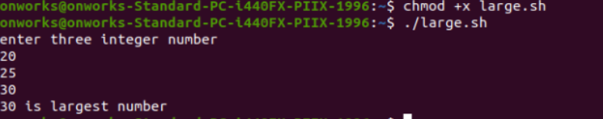

4**.** Write a shell script to compare two string.

## CODE:

echo “enter two string”

read a read b

if [ -z $a ] then

echo “ First String is empty: Null String”

fi

if [ -z $b ] then

echo “ First String is empty: Null String”

fi

if [ $a = $b ] then

echo “Strings are equal: strings Matched”

else

echo “Strings are not equal: Strings not match”

fi

**OUTPUT:**

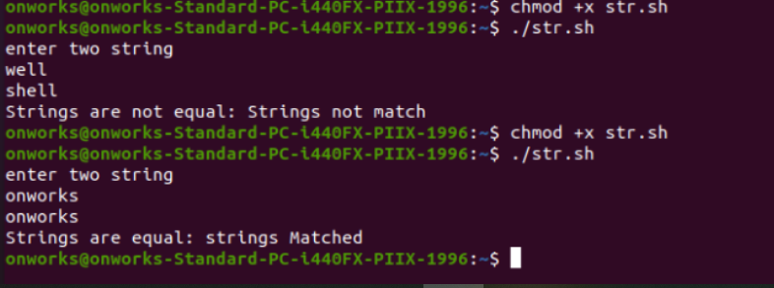

5.Write a shell script to read and check the directory exists or not, if not make directory.

## CODE:

echo “enter name of directory”

read dir

if [ -d $dir ] then

echo “Directory $dir Exits!”

else

mkdir $dir fi **OUTPUT:**

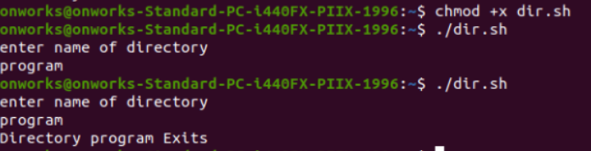

6.Write a shell script to read and check the file exists or not, if not make file.

## CODE:

echo “enter name of file”

read filename

if [ -f $filename ] then

echo “File $filename Exits!”

else

touch $filename fi

**OUTPUT:**

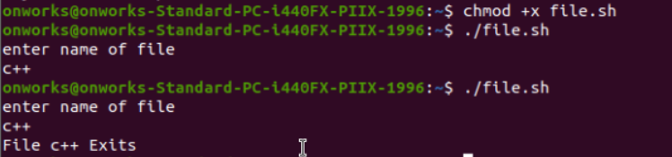

7.Write a shell script to implement menu driven program to perform all arithmetic operation using case statement.

## CODE:

echo “enter two integer values”

read a read b

echo –e “Menu \n 1 for Addition \n 2 for Substraction \n 3 for Multiplication \n 4 for Division \n 5 for Remainder”

echo “enter choice”

read ch case $ch in

1. echo “Sum=$(expr $a + $b)”;;
2. echo “Substraction=$(expr $a - $b)”;;
3. echo “Multiplication=$(expr $a \* $b)”;;
4. echo “Division=$(expr $a / $b)”;;
5. echo “Remainder=$(expr $a % $b)”;;
6. echo “invalid Choice:Try Again!”

esac

## OUTPUT:

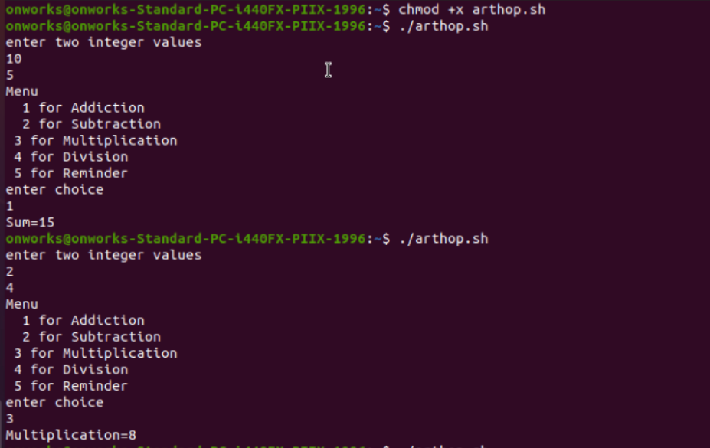

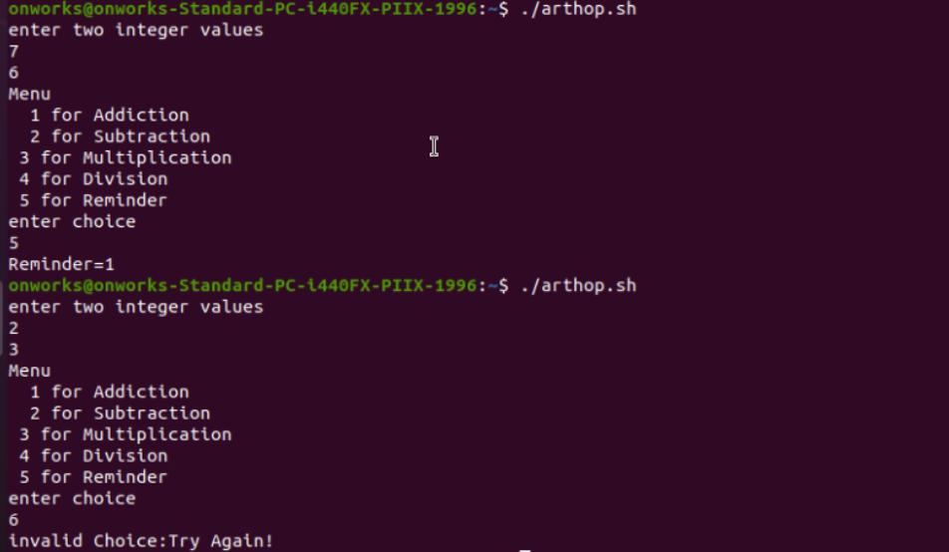

8. Write a shell script to do:

* 1. display list of directory contents
  2. Name of current directory
  3. Who is logged on
  4. Long listing of directory contents according to choose of user.

## CODE:

echo –e “Menu \n 1 for listing directory content \n 2 for print name of current directory \n 3 for Show who is logged on \n 4 Show directory content using long listing format “

echo “enter your choice “

read ch case $ch in

1. ls;;
2. pwd;;
3. who;;
4. ls –l;;

*) echo “Invalid Choice: Try Again!!”

esac

## OUTPUT:

## 

## 

9. Write a shell script to getting input details like name, roll number and marks and print them. using command line arguments.

## CODE:

cat > Studentdetail

echo "Name of the student: $1"

echo "Roll Number of the student: $2" echo "Marks of the student: $3" **OUTPUT:**

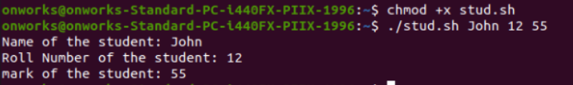

10**.** Understand the differences between Echo statement using single quote , double quote and without quotes.

**CODE**:

Cat< file1.sh a=12

echo $a echo "$a" echo '$a' **OUTPUT:**

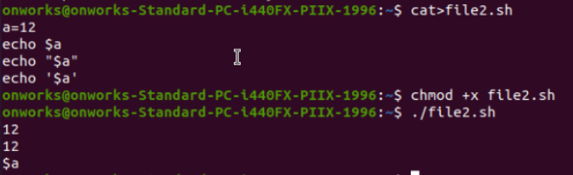

11.To check whether there is any entry in the FISAT.

**CODE:**

cat > fisat.txt

cat fisat.txt | grep “fisat”

## OUTPUT:

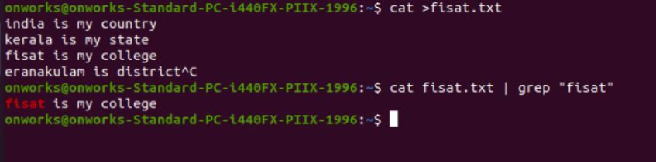

13.Implement arithmetic calculator using Functions

## CODE:

## Add()

## {

## i=$2

j=$2 ((k=i- j))

echo Sum is $k

}

mul()

{

i=$1

j=$2

((k=i*j))

echo Sum is $k

}

echo "Enter your option: 1: Add, 2:Subtract, 3: Multiply" read i

case $i in 1) add 1 2;;

2) sub 1 2;;

3) mul 1 2;; esac **OUTPUT:**

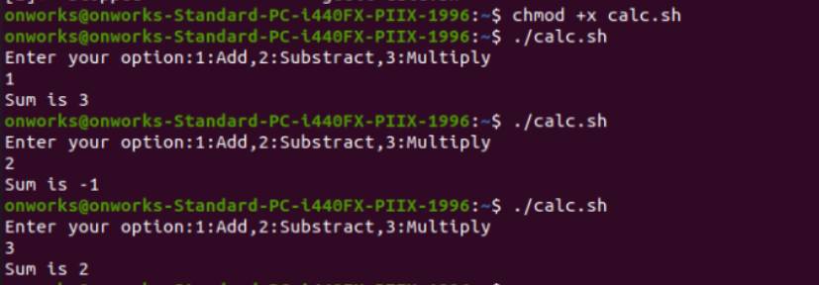

1. Using for loop

## CODE:

sum=0

for ((i=0;i<10;i++)) ((sum=sum+i)) done  
echo $sum

## OUTPUT:



b.Using While loop

## CODE:

i=0 sum=0

while ((i<10));do

((sum=sum+i))

((i=i+1))

Done

echo $sum

**OUTPUT:**



# EXPERIMENT- 4 FILE SYSTEM

It makes sense to explore the Linux filesystem from a terminal window,

In fact, that is the name of the first tool you’ll install to help you on the way: *tree*. If you are using Ubuntu or Debian, you can do: sudo apt install tree

Once installed, stay in your terminal window and run *tree* like this:

$ tree /

The / in the instruction above refers to the *root* directory. The root directory is the one from which all other directories branch off from. When you run tree and tell it to start with */*, you will see the whole directory tree, all directories and all the subdirectories in the whole system, with all their files, fly by.

If you have been using your system for some time, this may take a while, because, even if you haven’t generated many files yourself, a Linux system and its apps are always logging, caching, and storing temporary files. The number of entries in the file system can grow quite quickly.

Instead, try this:

tree -L 1 /

It makes sense to explore the Linux filesystem from a terminal window,

In fact, that is the name of the first tool you’ll install to help you on the way: *tree*. If you are using Ubuntu or Debian, you can do: sudo apt install tree

Once installed, stay in your terminal window and run *tree* like this:

$ tree /

The / in the instruction above refers to the *root* directory. The root directory is the one from which all other directories branch off from. When you run tree and tell it to start with */*, you will see the whole directory tree, all directories and all the subdirectories in the whole system, with all their files, fly by.

If you have been using your system for some time, this may take a while, because, even if you haven’t generated many files yourself, a Linux system and its apps are always logging, caching, and storing temporary files. The number of entries in the file system can grow quite quickly.

Instead, try this: tree -L 1 /

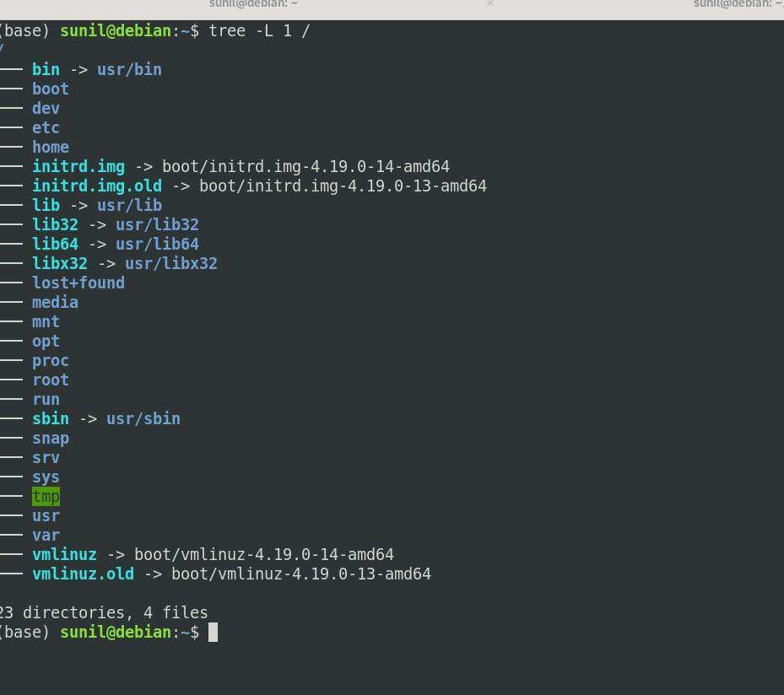

The instruction above can be translated as “show me only the 1st Level of the directory tree starting at / (root)“. The -L option tells tree how many levels down you want to see.

Most Linux distributions will show you the same or a very similar layout to what you can see in the image above. This means that even if you feel confused now, master this, and you will have a handle on most, if not all, Linux installations in the whole wide world.

## DIRECTORIES

From top to bottom, the directories you are seeing are as follows.

#### /bin

*/bin* is the directory that contains *bin*aries, that is, some of the applications and programs you can run. You will find the *ls* program mentioned above in this directory, as well as other basic tools for making and removing files and directories, moving them around, and so on. There are more *bin* directories in other parts of the file system tree, but we’ll be talking about those in a minute.

#### /boot

The */boot* directory contains files required for starting your system. If you mess up one of the files in here, you may not be able to run your Linux and it is a pain to repair.

On the other hand, don’t worry too much about destroying your system by accident:

you have to have superuser privileges to do that.

### /dev

/dev contains device files. Many of these are generated at boot time or even on the fly. For example, if you plug in a new webcam or a USB pendrive into your machine, a new device entry will automatically pop up here.

### /etc

/etc is the directory where names start to get confusing. /etc gets its name from the earliest Unixes and it was literally “et cetera” because it was the dumping ground for system files administrators were not sure where else to put.

Nowadays, it would be more appropriate to say that etc stands for “Everything to configure,” as it contains most, if not all system-wide configuration files. For example, the files that contain the name of your system, the users and their passwords, the names of machines on your network and when and where the partitions on your hard disks should be mounted are all in here. Again, if you are new to Linux, it may be best if you don’t touch too much in here until you have a better understanding of how things work.

### /home

/home is where you will find your users’ personal directories. In my case, under /home there are two directories: /home/paul, which contains all my stuff; and /home/guest, in case anybody needs to borrow my computer.

### /lib

/lib is where libraries live. Libraries are files containing code that your appli a ions can use. They contain snippets of code that applications use to draw windows on your desktop, control peripherals, or send files to your hard disk.

There are more lib directories scattered around the file system, but this one, the one hanging directly off of / is special in that, among other things, it contains the all- important kernel modules. The kernel modules are drivers that make things like your video card, sound card, WiFi, printer, and so on, work.

### /media

The /media directory is where external storage will be automatically mounted when you plug it in and try to access it. As opposed to most of the other items on this list, /media does not hail back to 1970s, mainly because inserting and detecting storage (pendrives, USB hard disks, SD cards, external SSDs, etc) on the fly, while a computer is running, is a relatively new thing.

### /mnt

The /mnt directory, however, is a bit of remnant from days gone by. This is where you would manually mount storage devices or partitions. It is not used very often nowadays.

### /opt

The /opt directory is often where software you compile (that is, you build yourself from source code and do not install from your distribution repositories) sometimes lands. Applications will end up in the /opt/bin directory and libraries in the /opt/lib directory.

A slight digression: another place where applications and libraries end up in is

/usr/local, When software gets installed here, there will also be /usr/local/bin and

/usr/local/lib directories. What determines which software goes where is how the developers have configured the files that control the compilation and installation process.

### /proc

/proc, like /dev is a virtual directory. It contains information about your computer, such as information about your CPU and the kernel your Linux system is running. As with

/dev, the files and directories are generated when your computer starts, or on the fly, as your system is running and things change.

### /root

/root is the home directory of the superuser (also known as the “Administrator”) of the system. It is separate from the rest of the users’ home directories BECAUSE YOU ARE NOT MEANT TO TOUCH IT. Keep your own stuff in you own directories, people.

### /run

/run is another new directory. System processes use it to store temporary a a for their own nefarious reasons.

### /sbin

/sbin is similar to /bin, but it contains applications that only the superuser (hence the initial s) will need. You can use these applications with the sudo command that temporarily concedes you superuser powers on many distributions. /sbin typically contains tools that can install stuff, delete stuff and format stuff. As you can imagine, some of these instructions are lethal if you use them improperly, so handle with care.

### /usr

The /usr directory was where users’ home directories were originally kept back in the early days of UNIX. However, now /home is where users kept their stuff as we saw

above. These days, /usr contains a mish-mash of directories which in turn contain applications, libraries, documentation, wallpapers, icons and a long list of other stuff that need to be shared by applications and services. the /bin directory (hanging off of root) would contain very basic commands, like ls, mv and rm; the kind of commands that would come pre-installed in all UNIX/Linux installations, the bare minimum to run and maintain a system. /usr/bin on the other hand would contain stuff the users would install and run to use the system as a work station, things like word processors, web browsers, and other apps.

/usr/bin just in case erasing it completely would break something. So, while Debian, Ubuntu and Mint still keep /bin and /usr/bin (and /sbin and /usr/sbin) separate; others, like Arch and its derivatives just have one “real” directory for binaries, /usr/bin, and the rest or *bins are “fake” directories that point to /usr/bin.

### /srv

The /srv directory contains data for servers. If you are running a web server from your Linux box, your HTML files for your sites would go into /srv/http (or /srv/www). If you were running an FTP server, your files would go into /srv/ftp.

### /sys

/sys is another virtual directory like /proc and /dev and also contains information from devices connected to your computer. In some cases you can also manipulate those devices. I can, for example, change the brightness of the screen of my laptop by modifying the value stored in the

### /tmp

/tmp contains temporary files, usually placed there by applications that you are running. The files and directories often (not always) contain data that an application doesn’t need right now, but may need later on.

### /var

/var was originally given its name because its contents was deemed variable, in that it changed frequently.

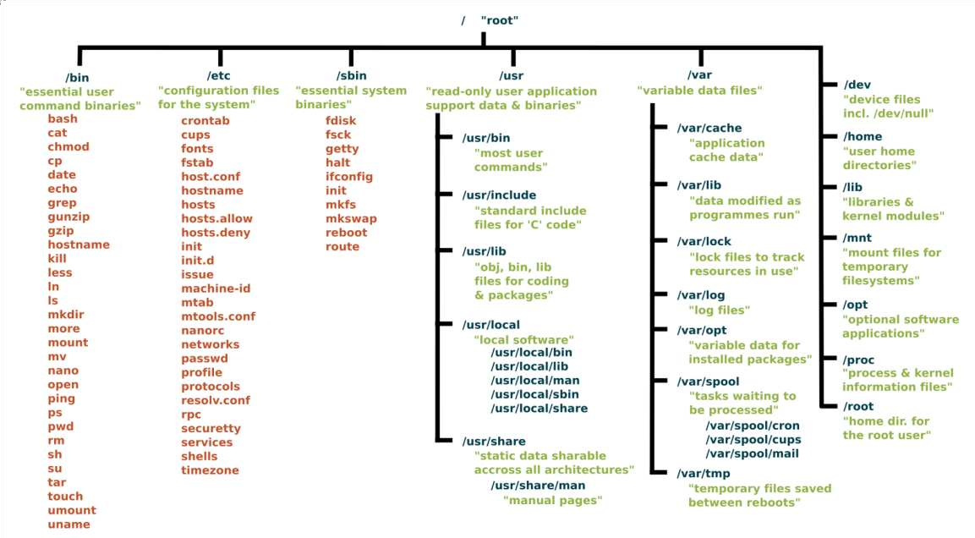

To explore the filesystem yourself, use the cd command: cd

will take you to the directory of your choice (cd stands for change directory. If you get confused,

pwd

will always tell you where you (pwd stands for print working directory). Also, cd

with no options or parameters, will take you back to your own home directory, where things are safe and cosy. Finally, cd ..

will take you up one level, getting you one level closer to the / root directory. If you are in /usr/share/wallpapers and run cd .., you will move up to /usr/share.

To see what a directory contains, use ls

or simply ls

to list the contents of the directory you are in right now.

And, of course, you always have tree to get an overview of what lays within a directory. Try it on /usr/share — there is a lot of interesting stuff in there.Although there are minor differences between Linux distributions, the layout for their filesystems are mercifully similar. So much so that you could say: once you know one, you know them all. And the best way to know the filesystem is to explore it. So go forth with tree, ls, and cd into uncharted territory.

# EXPERIMENT- 5

## LAMP SERVER INSTALLATION ON UBUNTU WITH APACHE

* 1. **STEP 1: PREPARING YOUR UBUNTU SERVER**

To begin with, you need a cloud server to run the LAMP stack software. If you are new to UpCloud, have a look at our quick started guide for [deploying your](https://upcloud.com/community/tutorials/deploy-server/) [first cloud server](https://upcloud.com/community/tutorials/deploy-server/) and [how to connect to it](https://upcloud.com/community/tutorials/connecting-to-your-server/). First of all, ensure everything is up to date on your server:

sudo apt update

sudo apt upgrade

Now open ports 22 (for SSH), 80 and 443 and enable Ubuntu Firewall (ufw):

sudo ufw allow ssh sudo ufw allow 80 sudo ufw allow 443

sudo ufw enable

### Step 2: Installing and testing Apache2

Install Apache using apt:

sudo apt install apache2

Confirm that Apache is now running with the following command:

sudo systemctl status apache2

You should the get an output showing that the apache2.service is running and enabled.

* apache2.service - The Apache HTTP Server

Loaded: loaded (/lib/systemd/system/apache2.service; enabled; vendor preset: enabled)

Active: active (running) since Tue 2020 -11-03 10:32:26 UTC; 1min 6s ago

Docs: https://httpd.apache.org/docs/2.4/

Main PID: 52943 (apache2)

Tasks: 7 (limit: 2282)

Memory: 11.9M

CGroup: /system.slice/apache2.service

├─52943 /usr/sbin/apache2 -k start

├─52944 /usr/sbin/apache2 -k start

├─52945 /usr/sbin/apache2 -k start

├─52946 /usr/sbin/apache2 -k start

├─52947 /usr/sbin/apache2 -k start

├─52948 /usr/sbin/apache2 -k start

└─52953 /usr/sbin/apache2 -k start

Once installed, test by accessing your server’s IP in your browser:

<http://YOURSERVERIPADDRESS/>

You should see a page with an “Apache2 Ubuntu Default” header showing that Apache2 has been installed successfully. If you do not see this, please ensure that the previous commands in this section have completed without error

## STEP 3: INSTALLING AND TESTING PHP 7.4

PHP 7.4 is the latest available right now so let’s install that along with some

regularly used modules:

sudo apt install php7.4 php7.4-mysql php-common php7.4-cli php7.4-json php7.4-common php7.4-opcache libapache2-mod-php7.4

Check the installation and version:

php --version

Restart Apache for the changes to take effect:

sudo systemctl restart apache2 Create a phpinfo.php test page:

echo '<?php phpinfo(); ?>' | sudo tee -a /var/www/html/phpinfo.php >

/dev/null

Test everything is working by accessing the following in your browser:

<http://YOURSERVERIPADDRESS/phpinfo.php>

You should see a PHP Version 7.4.3 page listing all of your PHP options. If you don’t or it tries to download a file, double-check that all of the above steps have completed without error. Once you’ve confirmed that PHP is working correctly, delete the test file.

sudo rm /var/www/html/phpinfo.php

The information displayed in the PHP info could be used to find an attack vector against your web server so best not to leave it publicly accessible.

## STEP 4: INSTALLING AND SECURING MARIADB

MariaDB is a fork of MySQL from some of the original MySQL team and is a drop-in replacement. We’ll be using this over MySQL itself in this guide!

Install the required packages:

sudo apt install mariadb-server mariadb-client

Once installed, check it’s running correctly:

sudo systemctl status mariadb

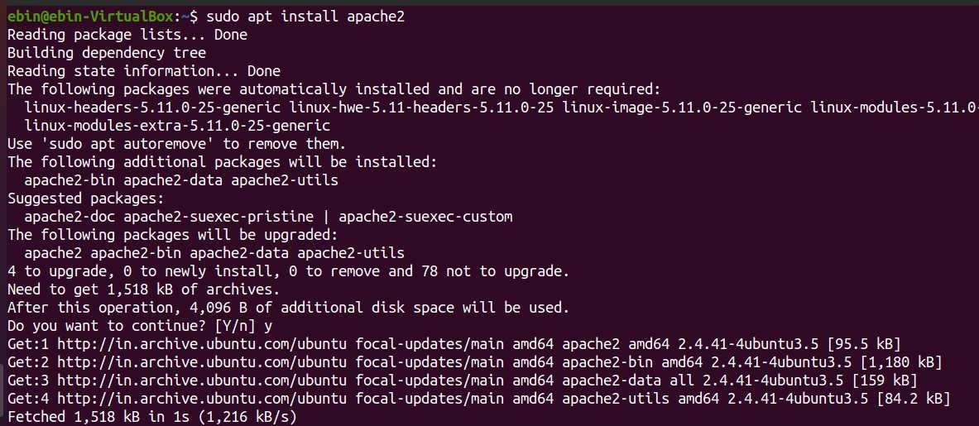

# EXPERIMENT- 6

## LARAVEL INSTALLATION ON UBUNTU WITH APACHE

**STEP 1 – INSTALL APACHE WEB SERVER**

Let’s open up a Terminal and do first thing first update your package list using Sudo

apt update command.

$ sudo apt update

After updating your package list install apache webserver

$ sudo apt install apache2

$ systemctl status apache2

Now, check the status of apache server whether it is running or not.

If the Apache server not running then use the following command to start apache serve and add to boot startup.

$ systemctl start apache2

$ systemctl enable apache2

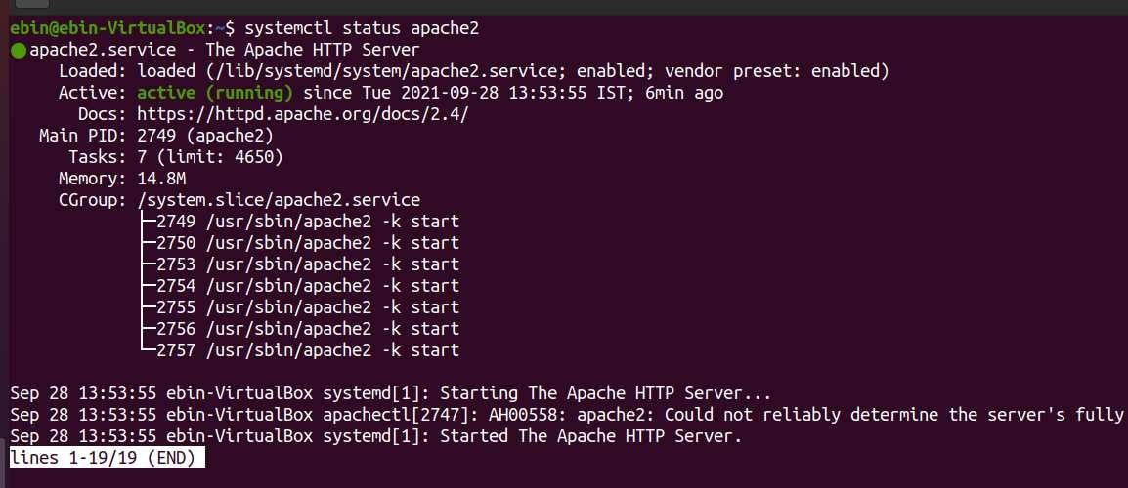

Open browser, goto localhost and check if default apache server page is available or not

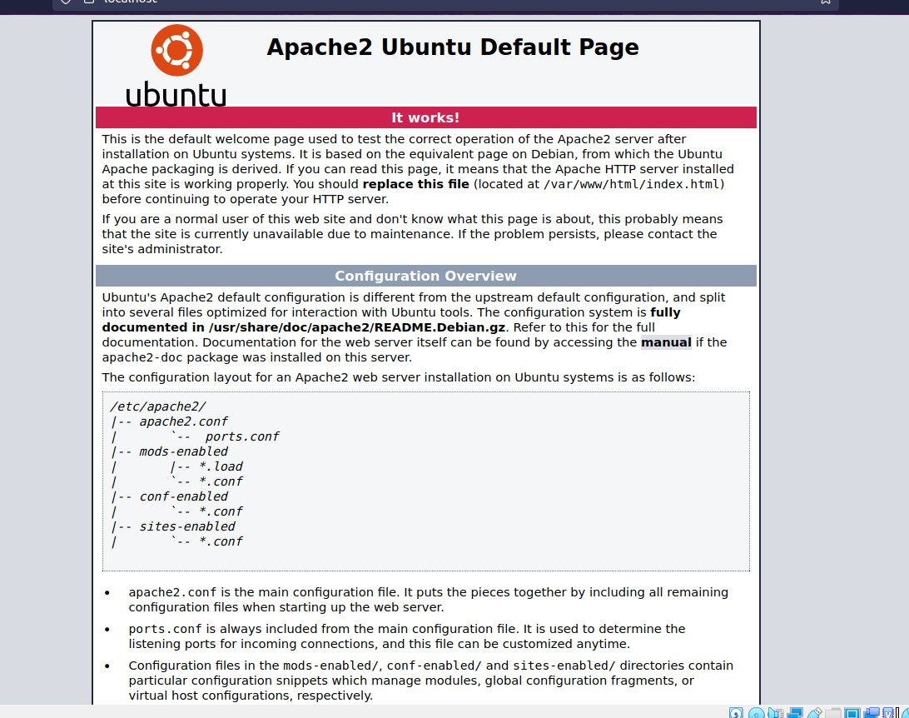

## STEP 2 – INSTALL AND CONFIGURE PHP 7.4

To install Laravel 8.x, at least you must have PHP >= 7.3 on your system. And by default, the official Ubuntu 20.04 repository provides PHP 7.4 packages. Install PHP

7.4 packages using the apt command below.

### $ sudo apt install libapache2-mod-php php php-common php-xml php-gd php- opcache php-mbstring php-tokenizer php-json php-bcmath php-zip unzip

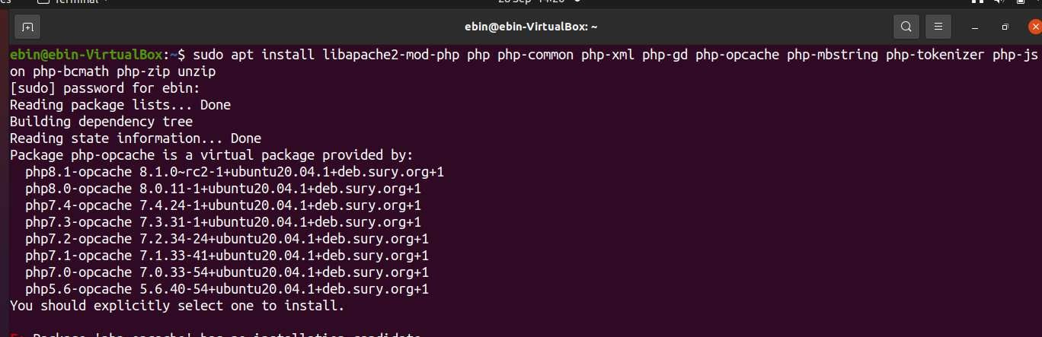

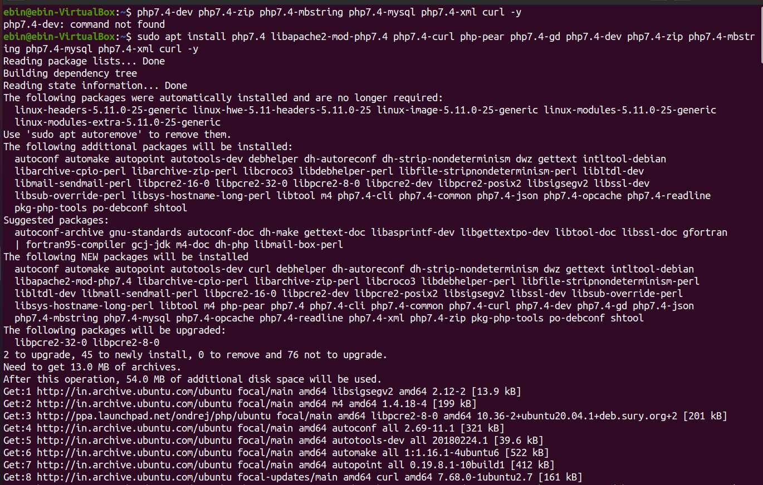

Now go ahead and make tweak changes in PHP ini file and set cgi.fix_pathinfo set to be 0. If this number is kept as a 1, the php interpreter will do its best to process the file that is as near to the requested file as possible. This is a possible security risk. If this number is set to 0, conversely, the interpreter will only process the exact file path—a much safer alternative.

### $ cd /etc/php/7.4/apache2

**$ sudo nano php.ini**

Press ctrl+w and search for the word “cgi.fix” the uncomment the line and set it to 0.

...

### cgi.fix_pathinfo=0

...

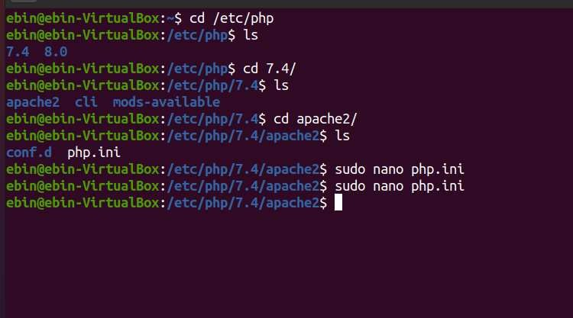

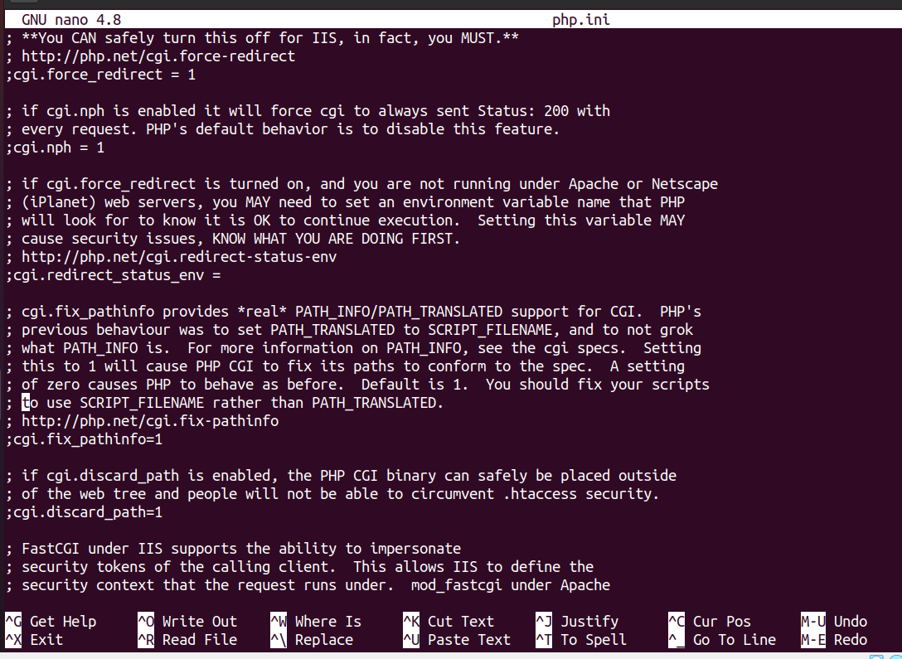

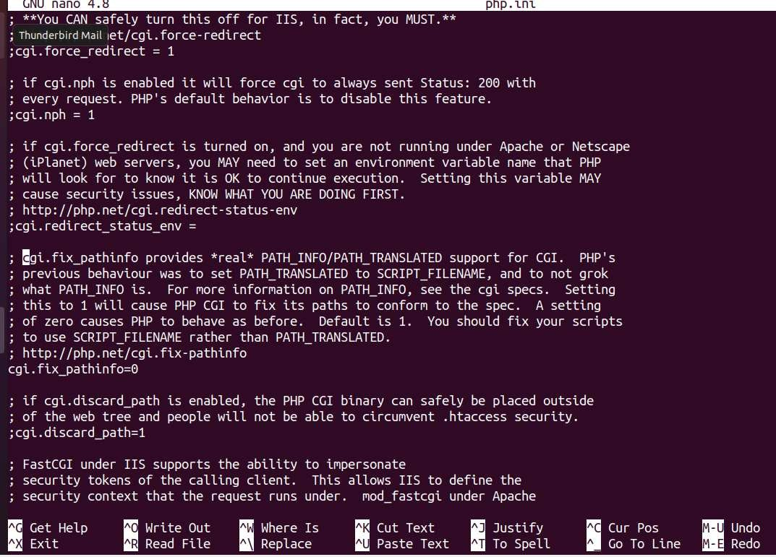

Press Ctrl + x then y to Save and Exit. Now Restart The apache service.

**$ systemctl restart apache2**

## STEP 3 – INSTALL COMPOSER PHP PACKAGES MANAGEMENT

Install the composer package manager go ahead and download and install Composer. and move the composer .phar file to usr/local/bin/composer directory.

**$ sudo apt install curl**

**$ curl -sS https://getcomposer.org/installer | php**

**$ sudo mv composer.phar /usr/local/bin/composer**

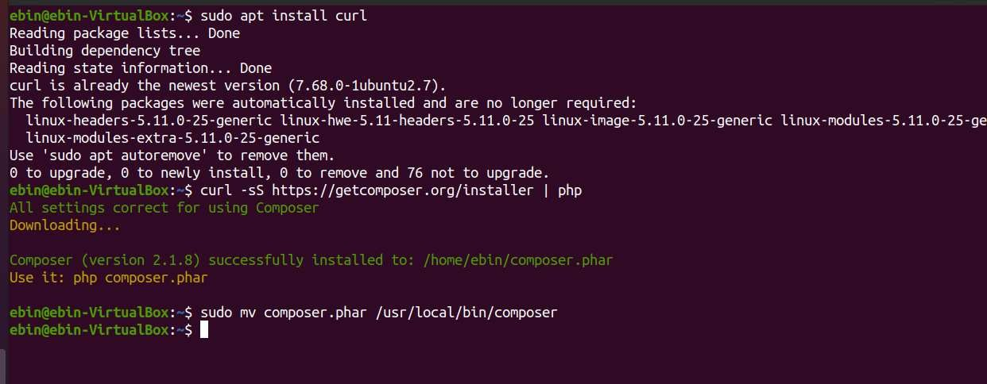

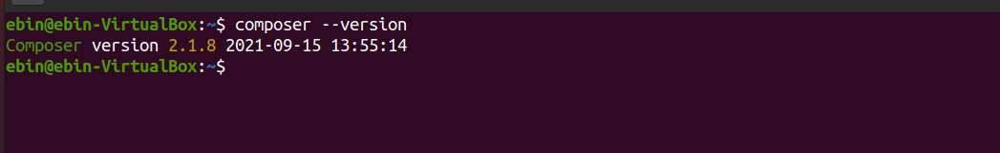

## STEP 4 – INSTALL LARAVEL 8.X ON UBUNTU 20.04

Now install Laravel Framework using composer, just type composer global require Laravel/installer It will take a while to complete download its dependencies.

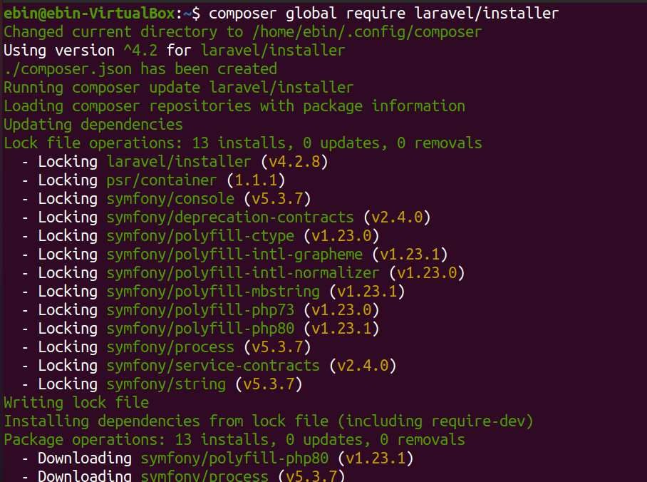

As you had seen above image, all packages have been installed on the

‘~/.config/composer’ directory. Next, we need to add the ‘bin’ directory to the PATH

environment through the ~/.bashrc configuration. So Now Edit the ~/.bashrc configuration using nano command.

### $ nano ~/.bashrc

And add the following line at the end of the file.

...

### export PATH="$HOME/.config/composer/vendor/bin:$PATH"

...

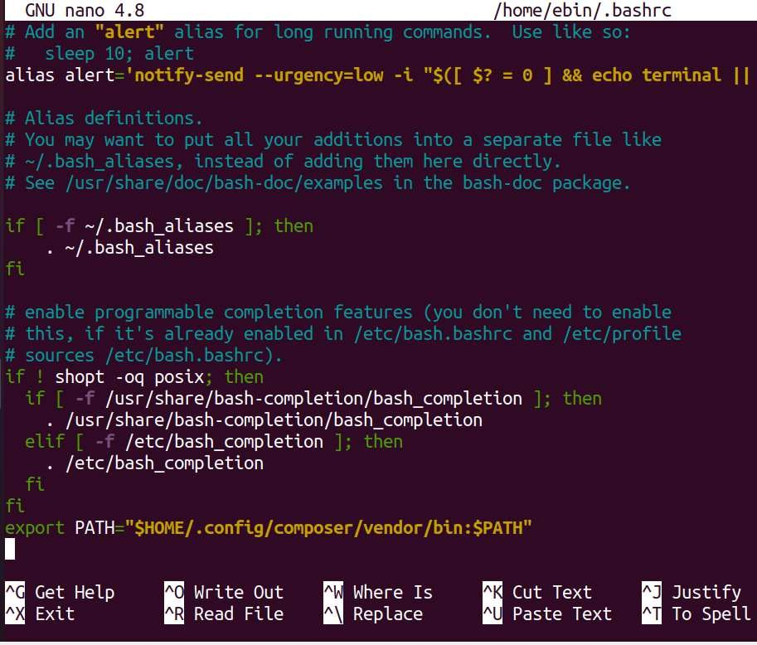

Press Ctrl + x then y to Save and Exit.

Now reload your bashrc configuration using the source command.

### $ source ~/.bashrc

Now echo $PATH. It will return your “Bin” directory path for the Composer package.

### $ echo $PATH

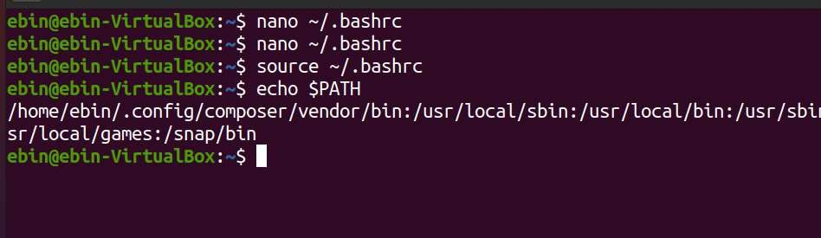

The ‘bin’ directory for the composer packages has been added to the $PATH environment variable. And as a result, you can use the command ‘laravel’ to start and create a new project. Now go ahead and type Laravel new then your project name to start a new Laravel project.

### $ laravel new myapp1

This will take a while to download all dependencies required by Laravel.

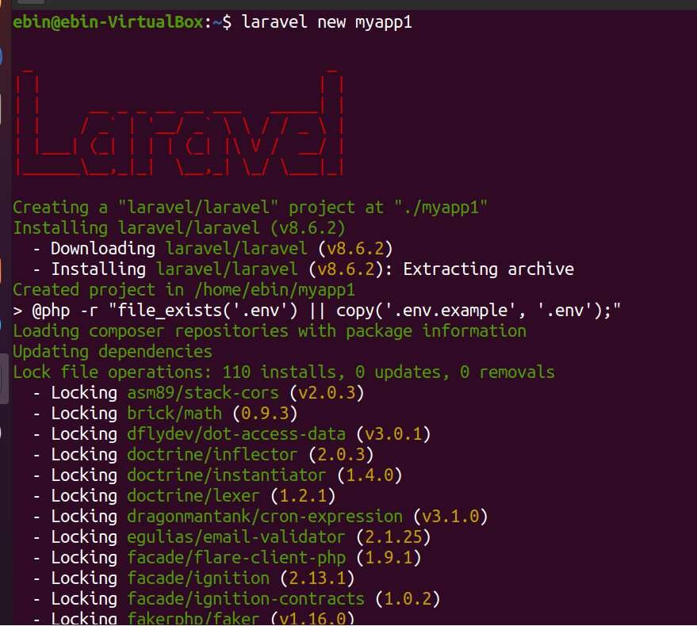

Here you can see the installation of my new project myapp1 finished. You can also see inside my home directory a new directory has been created with my project name.

## STEP 5 – FINALLY CONFIGURE APACHE FOR LARAVEL AND TEST IT

First, add your project directory to www-data group use the following command

### $ sudo chgrp -R www-data /home/ebin/myapp1

-R flag is recursive, Recursive means all subdirectory and files under your project

directory become changed to the “www-data” group.

Also, you need to change access permission 775 of the storage directory under your project. So, go ahead and use the following command.

### $ sudo chmod -R 775 /home/ebin/myapp1/storage

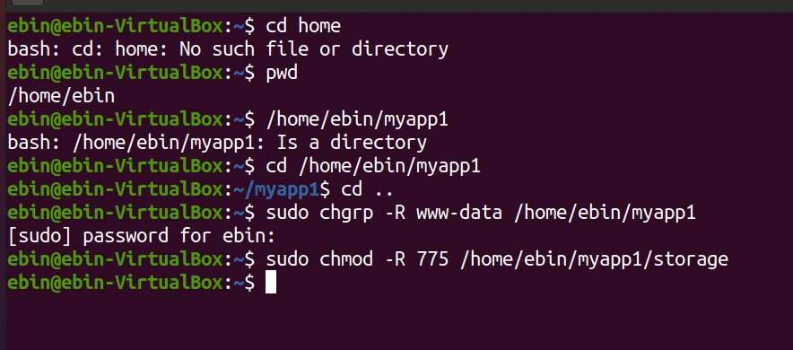

Now create an apache vhost configuration go to the following directory and create a vhost config file using nano file editor.

### $ cd /etc/apache2/sites-available/

**$ sudo nano myapp1.com.conf**

And paste the following line inside the file.

<VirtualHost *:80> ServerName myapp1.com

ServerAdmin [admin@myapp1.com](mailto:admin@myapp1.com) DocumentRoot /home/ebin/myapp1/public

<Directory /home/ebin/myapp1> Options Indexes MultiViews

AllowOverride None Require all granted

</Directory>

ErrorLog ${APACHE_LOG_DIR}/error.log

CustomLog ${APACHE_LOG_DIR}/access.log combined

</VirtualHost>

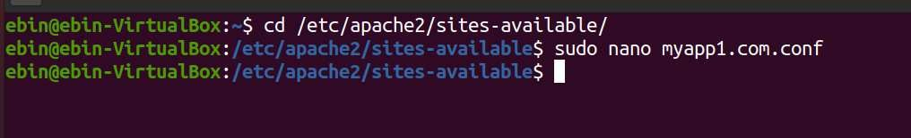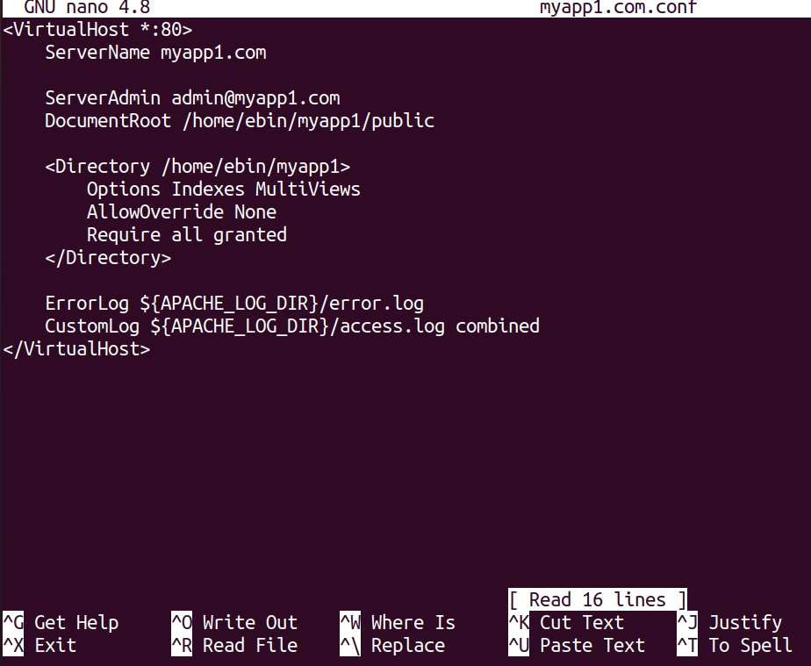

Now enable mod rewrite for apache2 just type

$ sudo a2enmod rewrite

Now enable your site, just type

$ sudo a2ensite myapp1.com.conf Finally, Restart the apache service, type

$ systemctl restart apache2

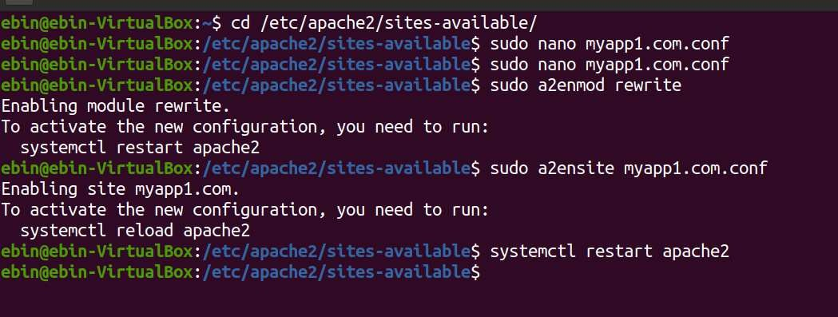

As you are in a local environment you need a local dns resolver for your site. Go ahead and edit /etc/hosts file, add a dns record for your site then save the file.

### $ sudo nano /etc/hosts

...

### 127.0.0.1 myapp1.com

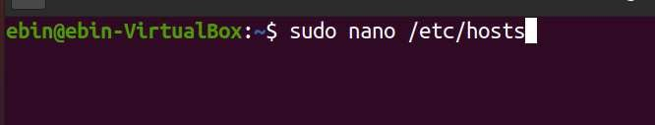

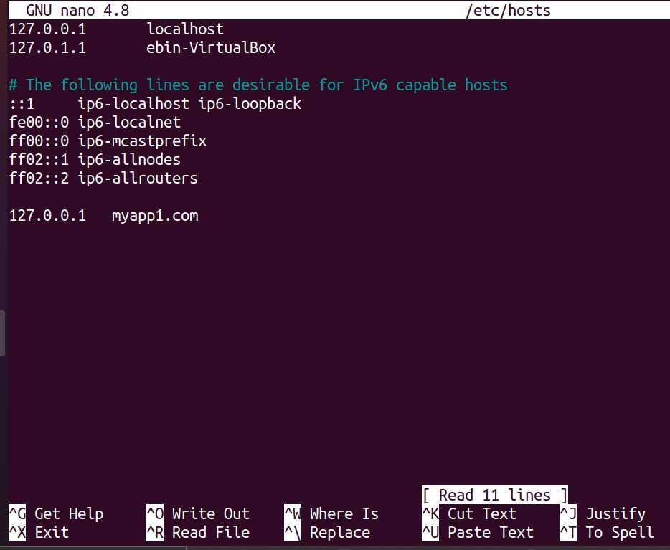

Now get back to the web browser and open a tab then type your project hostname.

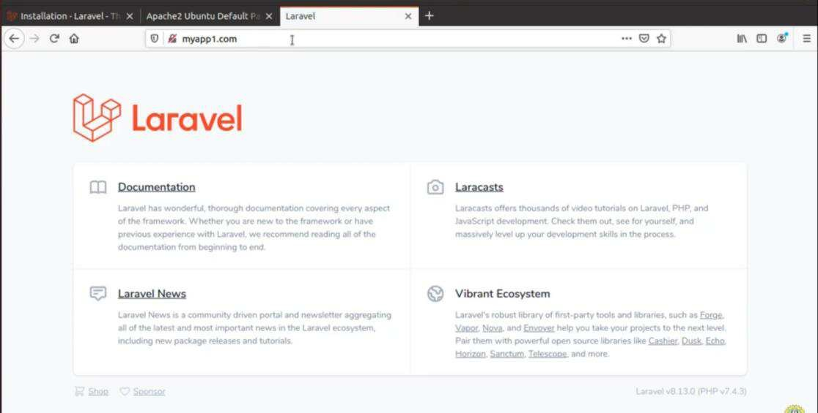

And here it is it’s working. Here you can see the Laravel version and PHP version.

# EXPERIMENT- 7

## NETWORK COMMANDS

**PING COMMAND:-**

PING (Packet Internet Groper) command is used to check the network connectivity between host and server/host. This command takes as input the IP address or the URL and sends a data packet to the specified address with the message “PING” and get a response from the server/host this time is recorded which is called latency. Fast ping low latency means faster connection. Ping uses ICMP(Internet Control Message Protocol) to send an ICMP echo message to the specified host if that host is available then it sends ICMP reply message. Ping is generally measured in millisecond every modern operating system has this ping pre-installed.

Syntax: ping [OPTIONS] DESTINATION

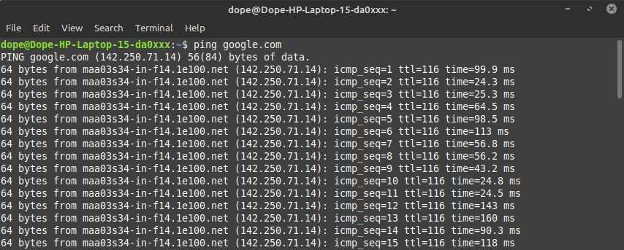

## TRACEROUTE COMMAND:-

Traceroute command in Linux prints the route that a packet takes to reach the host. This command is useful when you want to know about the route and about all the hops that a packet takes. Below image depicts how traceroute command is used to reach the Google (172.217.26.206) host from the local machine and it also prints detail about all the hops that it visits in between.

Syntax: traceroute [options] host_Address [pathlength]

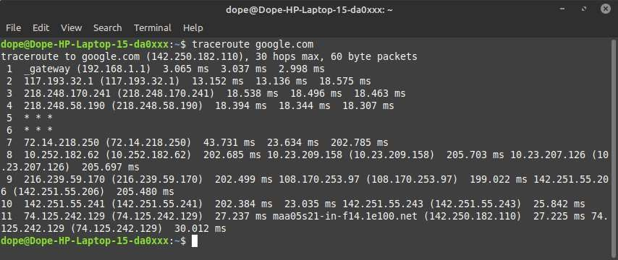

## ROUTE COMMAND

**Route** command in Linux is used when you want to work with the IP/kernel routing table. It is mainly used to set up static routes to specific hosts or networks via an interface. It is used for showing or update the IP/kernel routing table.

**Syntax:** route

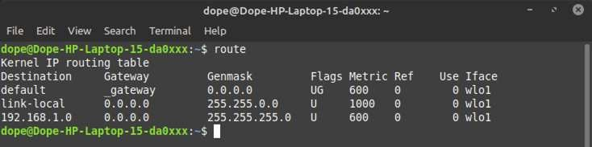

## NSLOOKUP COMMAND

**Nslookup** (stands for “Name Server Lookup”) is a useful command for getting information from DNS server. It is a network administration tool for querying the Domain Name System (DNS) to obtain domain name or IP address mapping or any other specific DNS record. It is also used to troubleshoot DNS related problems.

**Syntax:** nslookup [option]

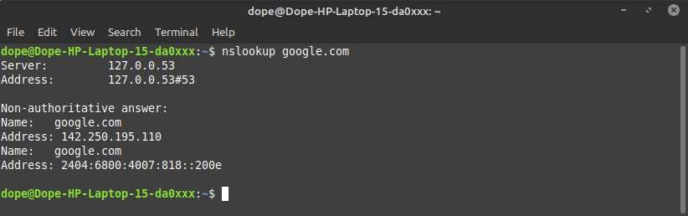

## IFCONFIG COMMAND

**ifconfig**(interface configuration) command is used to configure the kernel-resident network interfaces. It is used at the boot time to set up the interfaces as necessary. After that, it is usually used when needed during debugging or when you need system tuning. Also, this command is used to assign the IP address and netmask to an interface or to enable or disable a given interface.

**Syntax:** ifconfig [...OPTIONS] [INTERFACE]

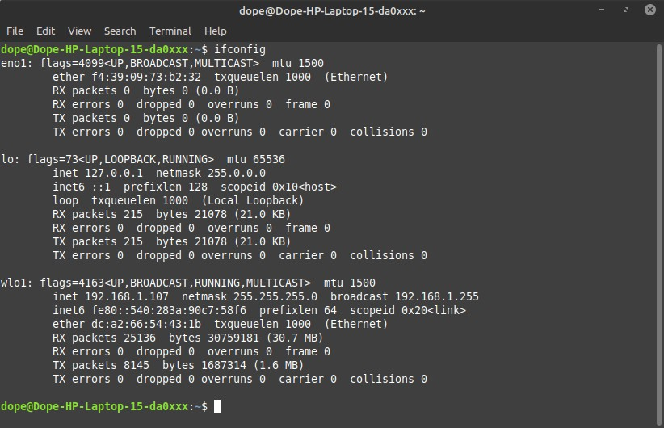

# EXPERIMENT- 8

## INTRODUCTION TO WIRESHARK

Wireshark is an open-source packet analyzer, which is used for education, analysis, software development, communication protocol development, and network troubleshooting. It is used to track the packets so that each one is filtered to meet our specific needs. It is commonly called as a sniffer, network protocol analyzer, and network analyzer. It is also used by network security engineers to examine security problems.

## FE ATURES OF WIRESHARK

* Available for UNIX and Windows.
* Capture live packet data from a network interface.
* Display packets with very detailed protocol information.
* Save packet data captured.
* Filter packet data on our criteria.
* Colorize packet data on our criteria.
* Export some or all packet data in a number of capture file formats.

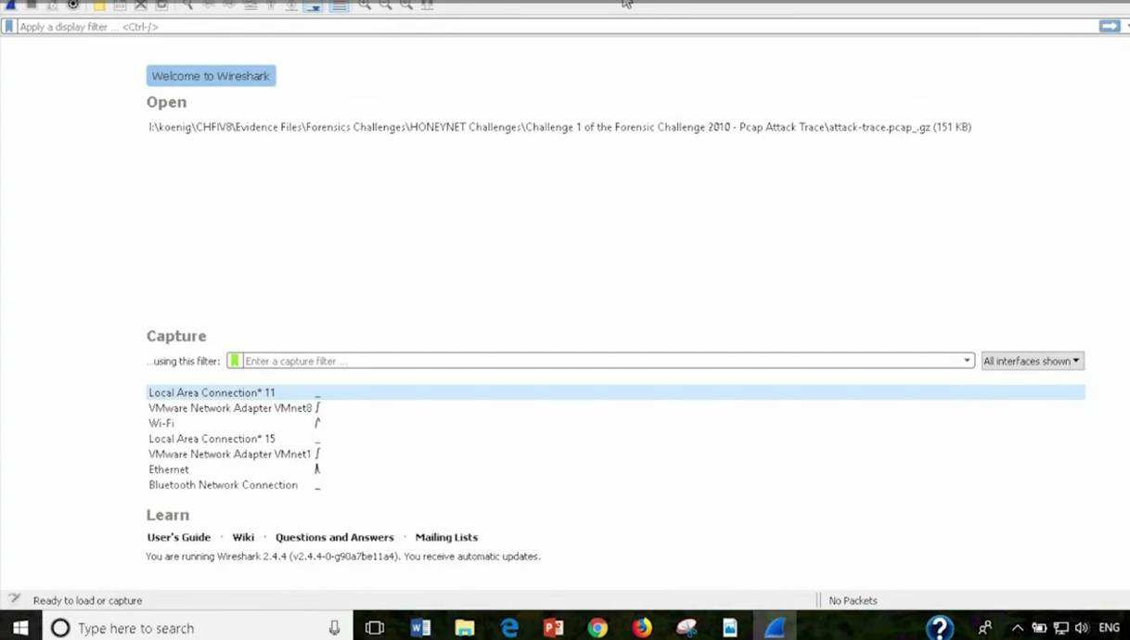

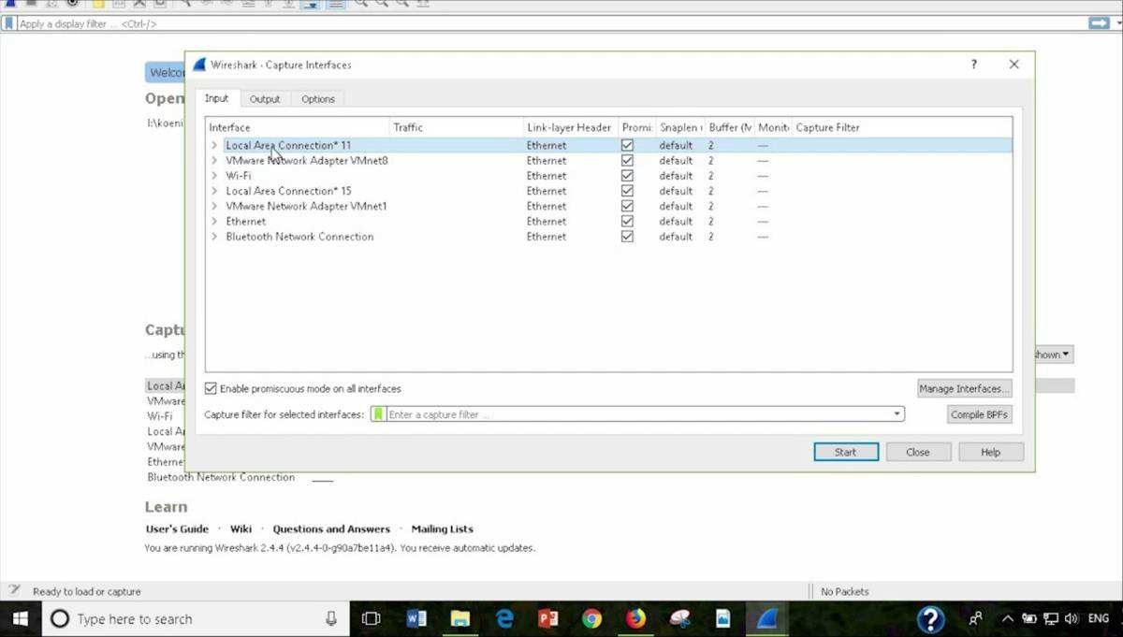

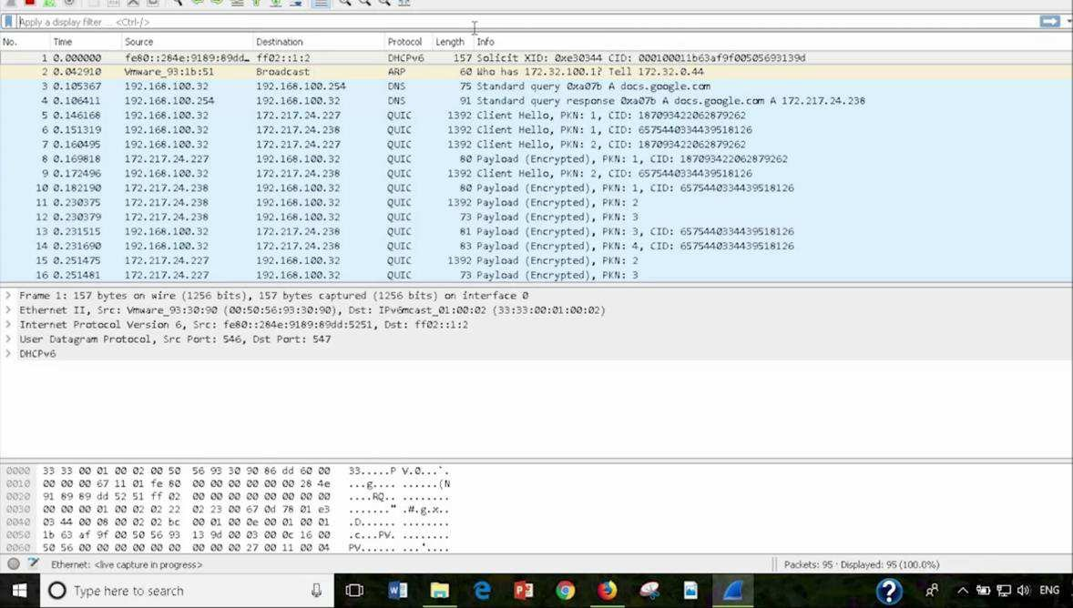

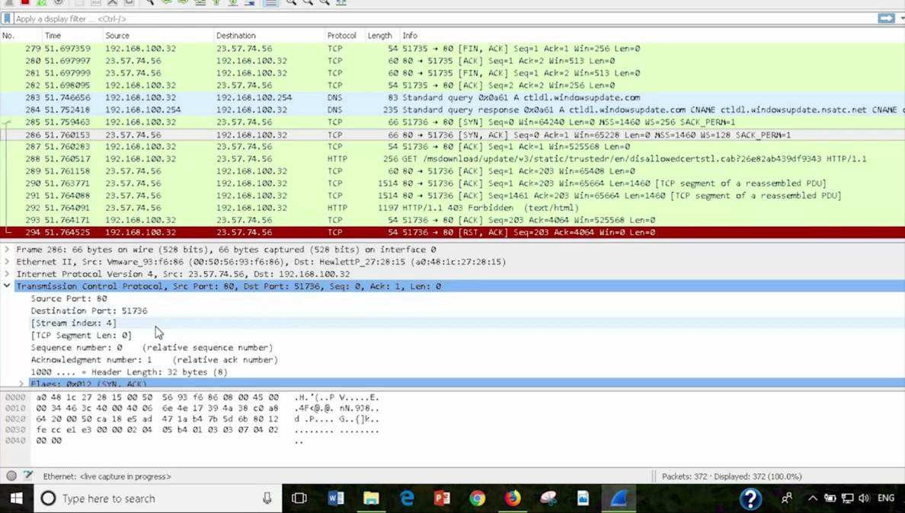

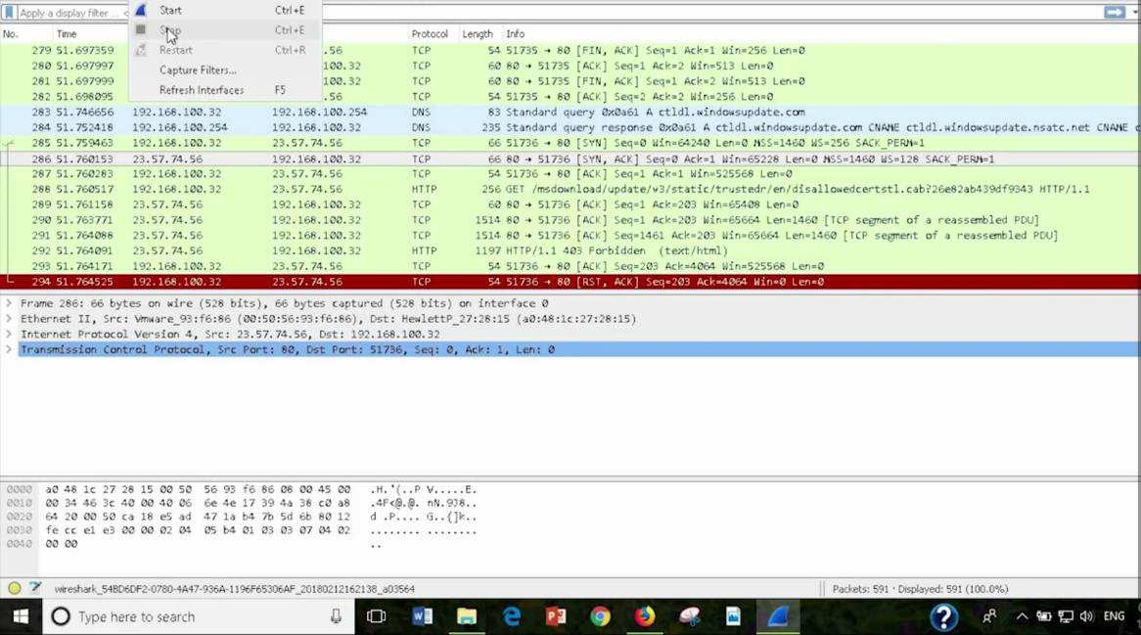

## HOW TO RETRIEVE WEB PAGES USING HTTP AND WIRESHARK TO CAPTURE THE PACKETS:-

1. Start up your web browser.
2. Start up the Wireshark packet sniffer (but don’t yet begin packet capture).

* Enter “http” (just the letters, not the quotation marks) in the display-filter specification

window, so that only captured HTTP messages will be displayed later in the packet-listing window.

1. Wait a bit more than one minute (we’ll see why shortly), and then begin

Wireshark packet capture.

1. Enter the following to your browser

TCP OR IP.ADDER == 192.168.100.32 .

Your browser should display the webpage.

1. Stop Wireshark packet capture.

**Your Wireshark window should look similar to the window shown in below Figure.**

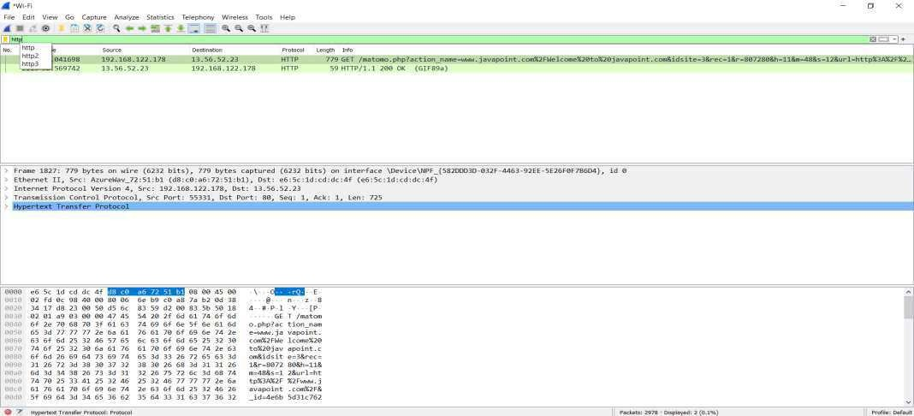

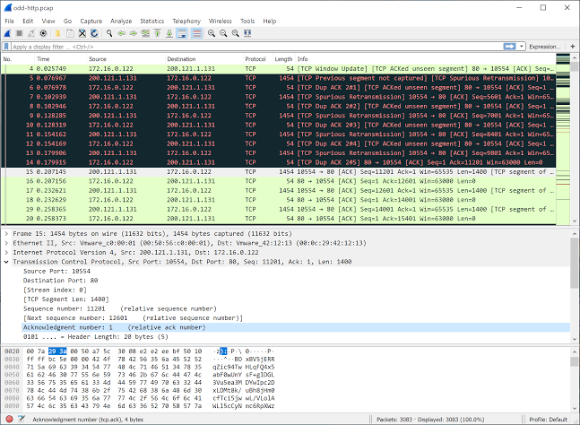

# EXPERIMENT- 9

## INTRODUCTION TO VIRTUAL BOX INSTALLATION

VirtualBox is designed to run virtual machines on your physical machine without reinstalling your OS that is running on a physical machine. One more VirtualBox advantage is that this product can be installed for free. A virtual machine (VM) works much like a physical one. An OS and applications installed inside a VM “think” that they are running on a regular physical machine since emulated hardware is used for running VMs on VirtualBox. Virtual machines are isolated from each other and from the host operating system. Thus, you can perform your tests in isolated virtual machines without any concerns of damaging your host operating system or other virtual machines.

**How to Set Up VirtualBox?**

The process of VirtualBox installation is not difficult and is similar for all supported operating systems.

### Enable CPU virtualization features

First, you need to enable hardware virtualization features on your CPU (Central Processor Unit) such as Intel VT-X or AMD-V in UEFI/BIOS of your physical computer. Otherwise, if you run 64-bit guest operating systems, you can get the error: VT-x is not available. If [Hyper-V](https://www.nakivo.com/hyper-v-backup/) is installed on your Windows machine, uninstall Hyper-V before installing VirtualBox (otherwise Hyper-V will block hardware virtualization extensions needed by VirtualBox to run VMs). The majority of modern processors support hardware virtualization.

### Download the VirtualBox installer

If you are looking for how to set up VirtualBox on mac, download the OS X installer. At the moment of writing this blog post, the latest VirtualBox version is 6.0.8. You can also download older versions, for example, version 5.2. VirtualBox 5.2 supports 32-bit hosts while VirtualBox 6.0 doesn’t. In the current example, you can see how to set up VirtualBox on an example of VirtualBox 5.2.

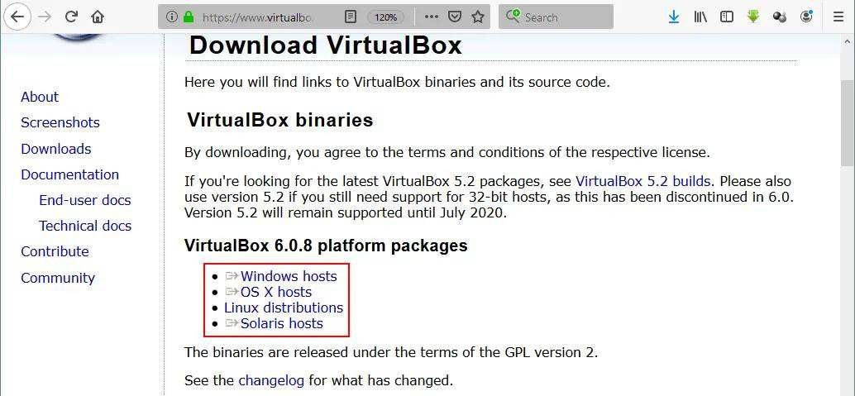

### Run the installer and define the installation options

Run the VirtualBox installer. The installation wizard that has a GUI (graphical user interface) should appear. Select the manner in which you want features to be installed, clicking on the installation directory and installed components—you can leave the default values. Then tick the checkboxes near shortcut options and file associations. After finishing installation, you can tick the checkbox for starting VirtualBox after installation.

### Deploying a New VM

Once you have installed VirtualBox, open the application. You can see the graphical user interface of VirtualBox which is unified for all supported host operating systems. You can also use the command line interface and VBox Manage if needed.

## CLICK NEXT:

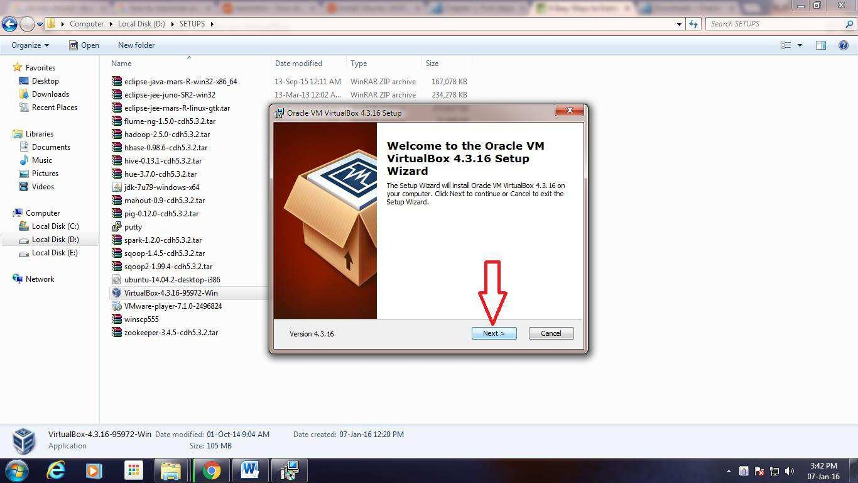

1. **CLICK NEXT:**

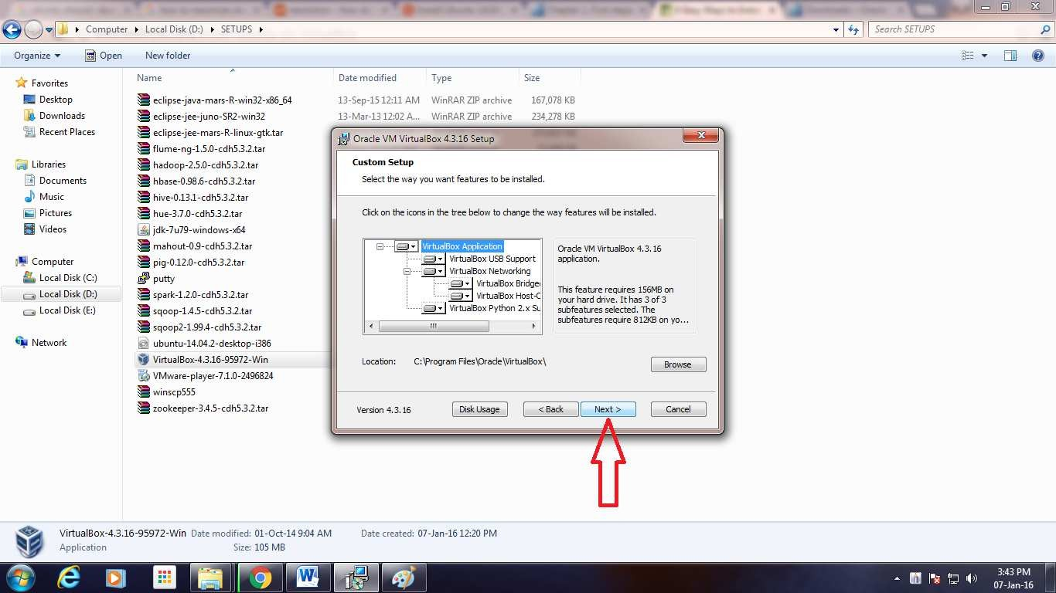

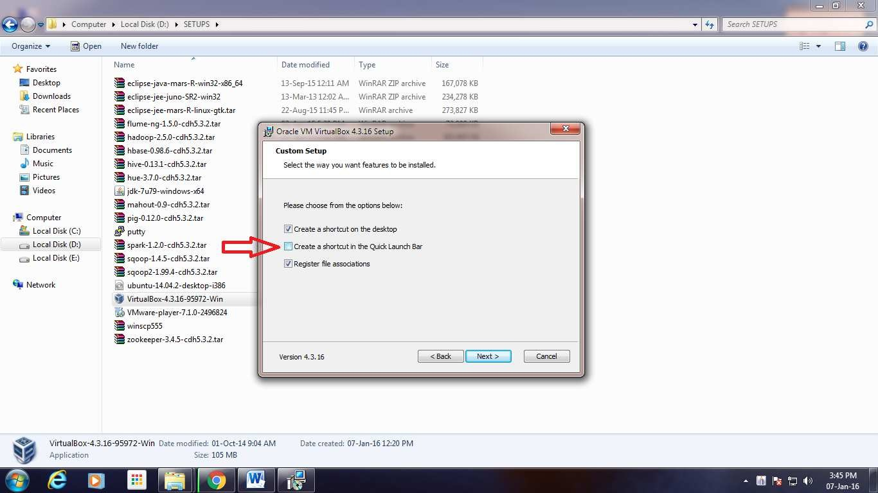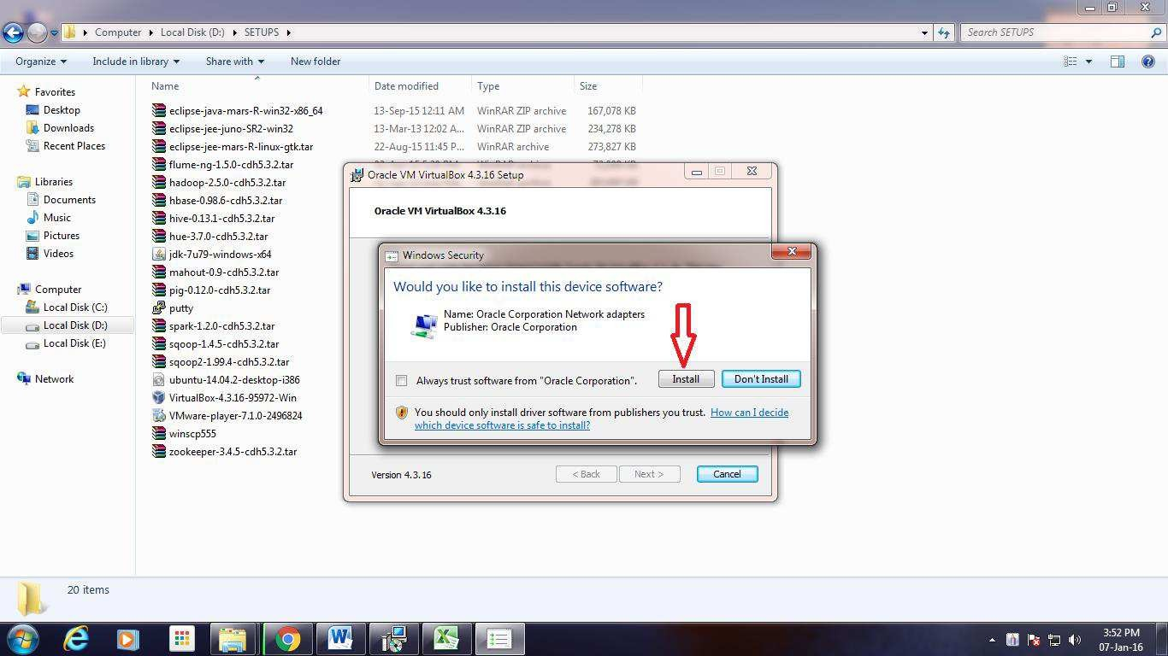

1. **UNCHECK “CREATE A SHORTCUT IN THE QUICK LAUNCH BAR” AND CLICK “NEXT”:**
2. **CLICK “INSTALL”**
3. **CLICK “FINISH”**

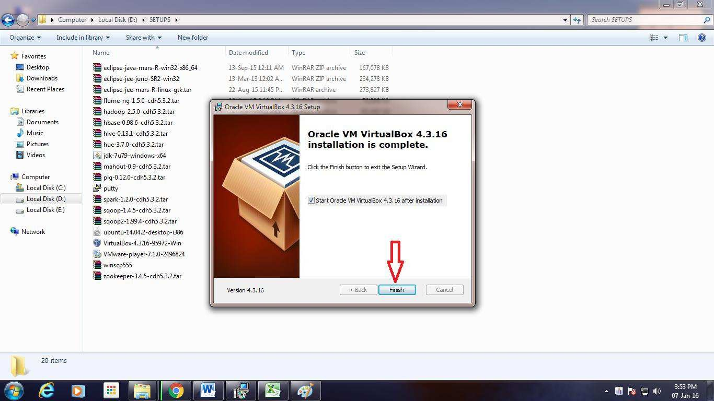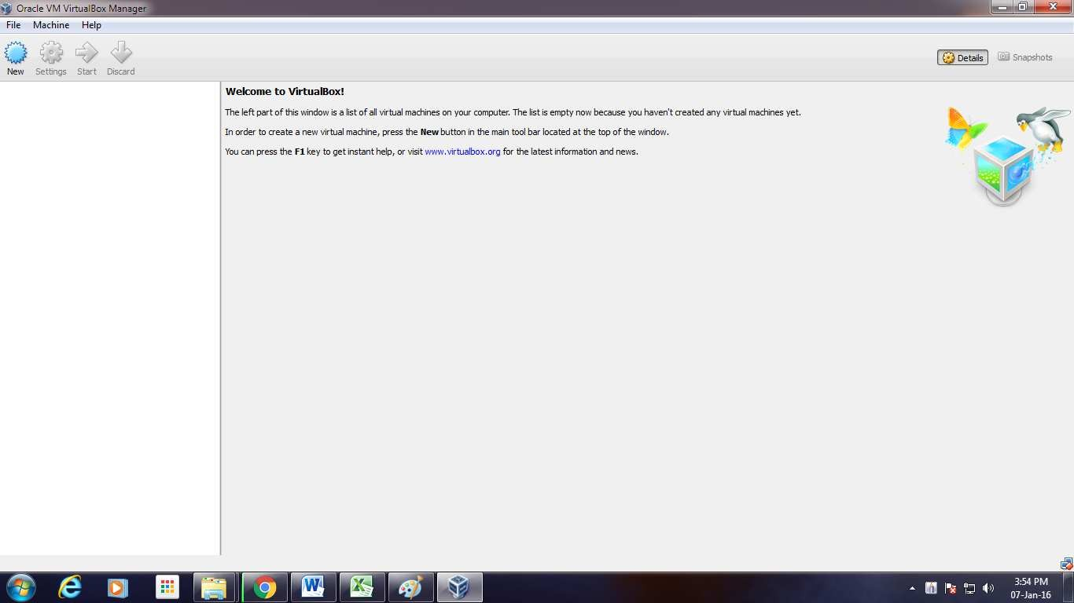

1. **AFTER COMPLETION OF INSTALLATION PROCESS, THE VIRTUAL BOX WINDOW GETS OPENED**

# EXPERIMENT- 10

**INTRODUCTION TO VIRTUAL MACHINES**

**CREATING A VIRTUAL MACHINE**

* 1. [**INSTALL VIRTUALBOX**](https://www.wikihow.com/Install-VirtualBox)

If you don't already have Virtual Box installed on your Windows or Mac computer, you'll need to install it before proceeding.

Following are the steps required to install Virtual Box (Oracle VM Virtual Box):

You can download the latest version of Virtual Box from the Virtual Box website: <https://www.virtualbox.org/wiki/Downloads>according to the version of your operating system Windows, Mac or Linux.

## CLICK NEXT



To Install Virtual Box – Setup Wizard

## CLICK NEXT



To Install VirtualBox – Custom Setup

* + 1. Uncheck “Create a shortcut in the Quick Launch Bar” and click “Next”



To Install Virtual Box – Features Selection

## CLICK “YES”

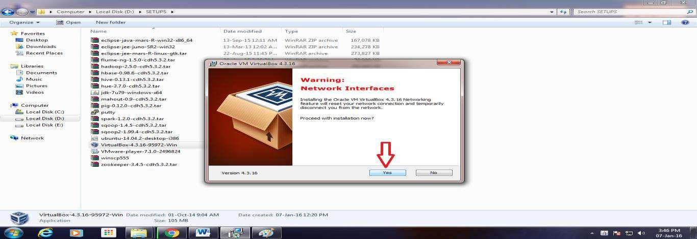

To Install Virtual Box – Network Interfaces Warning

## CLICK “INSTALL”

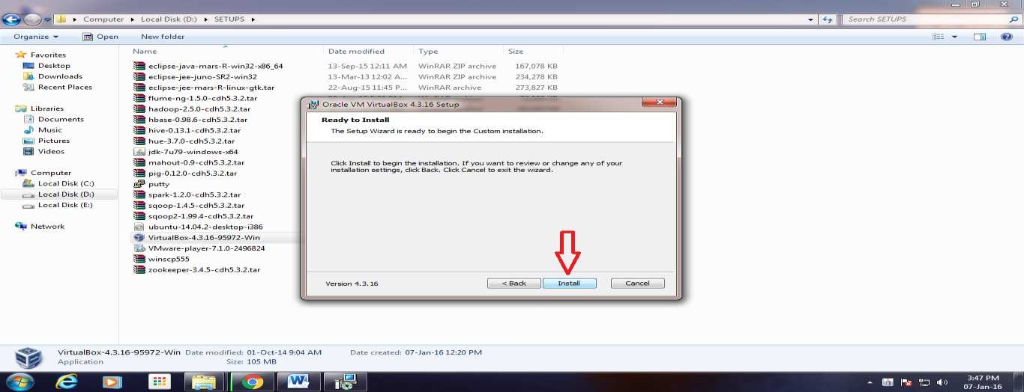

Installation of Oracle VM VirtualBox – Ready to Install

## CLICK “INSTALL”

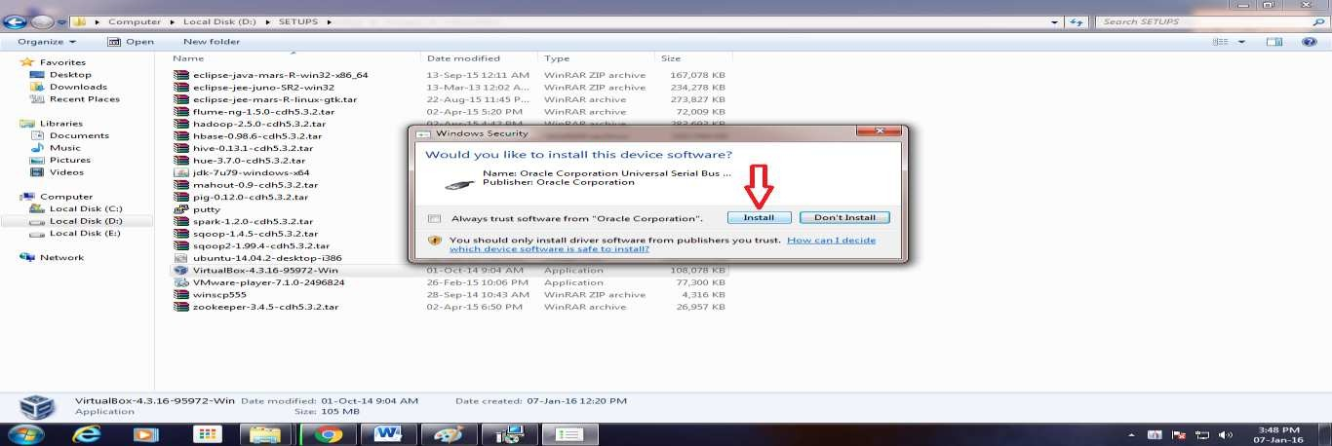

Installation of Oracle VM Virtual Box- Serial Bus Software Installation

## CLICK “INSTALL”

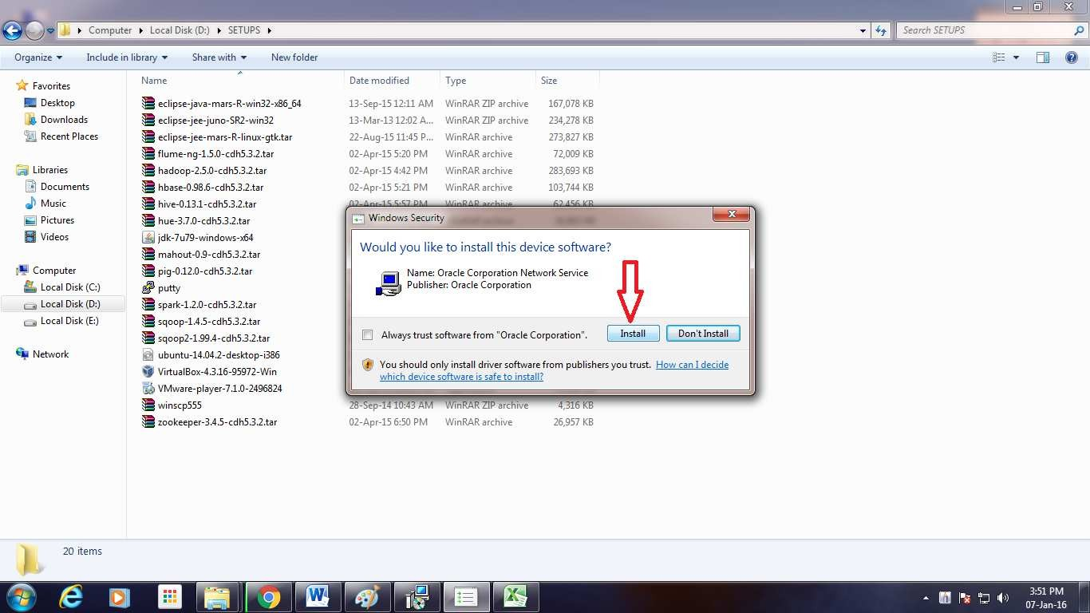

Installation of Oracle VM Virtual Box – Network Service Installation

## CLICK “INSTALL”



Installation of Oracle VM Virtual Box – Network Adapters Installation

## CLICK “FINISH”



* 1. Open Virtual Box. Double-click (or click once on a Mac) the Virtual Box app icon.

### 3.

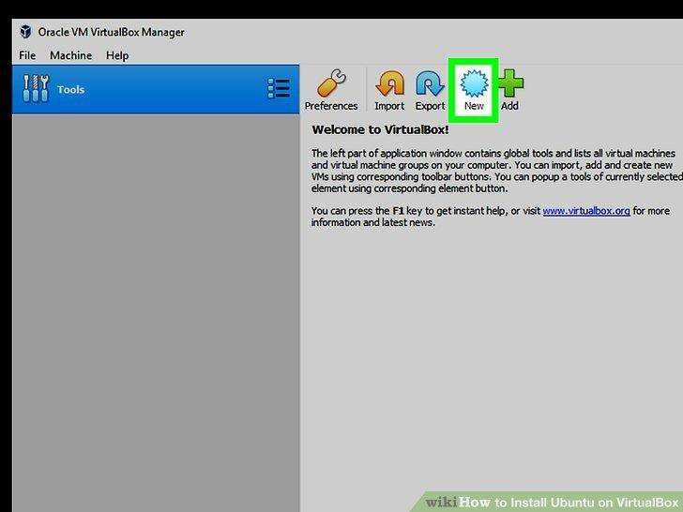

Click New**.** It's a blue badge in the upper-left corner of the Virtual Box window. Doing so opens a pop-up menu.

### 4.

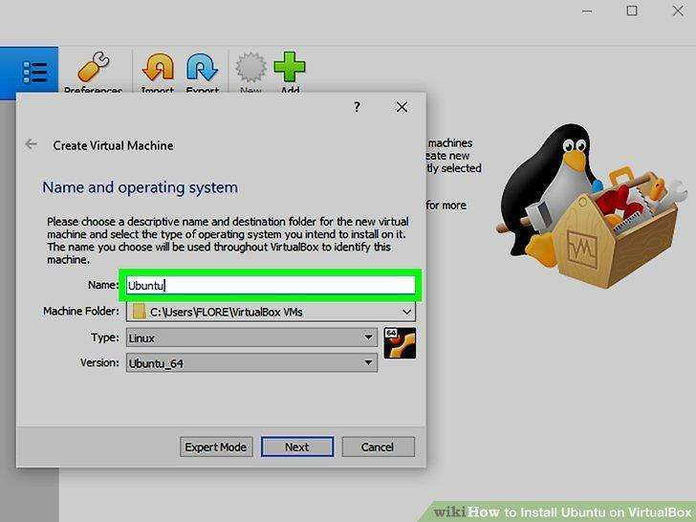

Enter a name for your virtual machine. Type whatever you want to name your virtual machine (e.g., Ubuntu) into the "Name" text field that's near the top of the pop-up menu.

### 5.

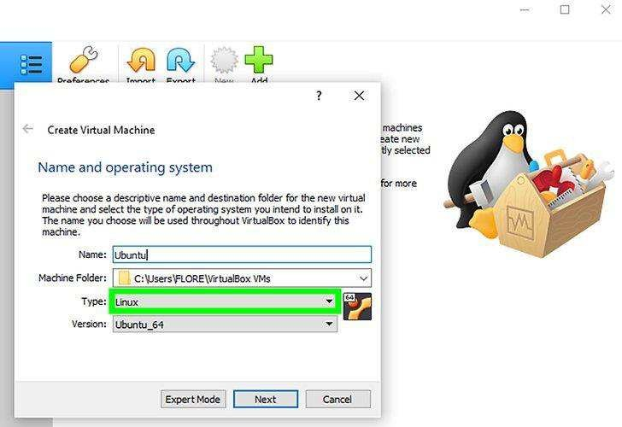

For Operating System Type, select the OS that you want to install.

### 6.

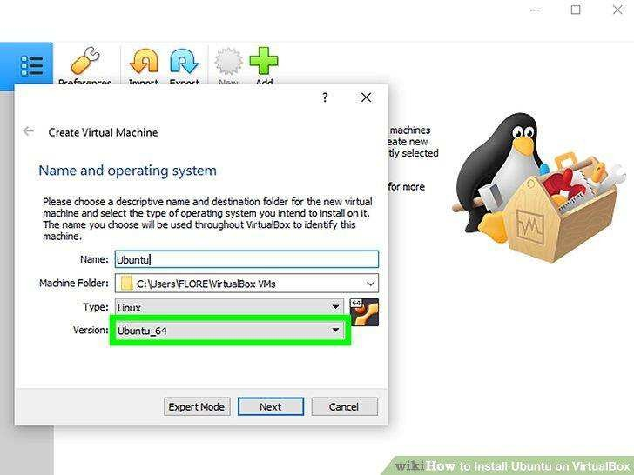

Select the **version** of the operating system.

# 7.

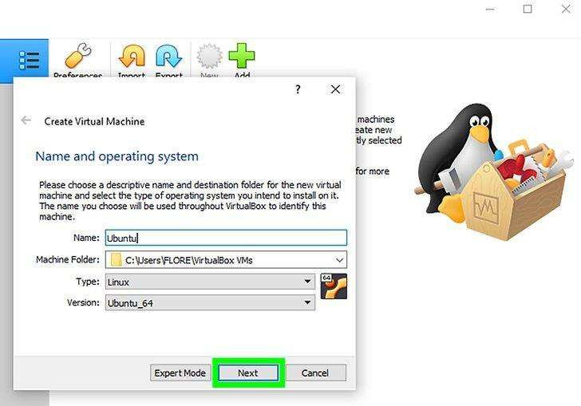

Click Next. It's at the bottom of the menu.

### 8.

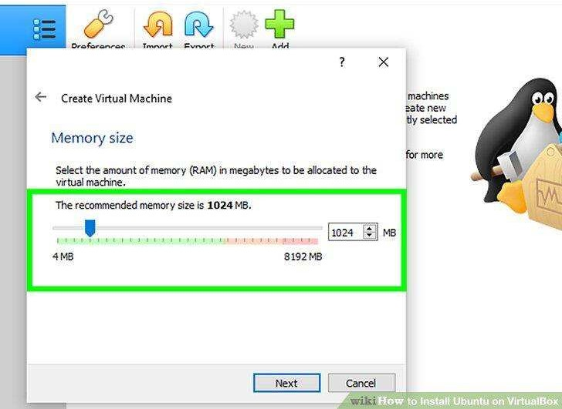

Select an amount of RAM to use. Click and drag the slider left or right to decrease or increase the amount of RAM that VirtualBox will have available for your virtual machine.

The ideal amount of RAM will automatically be selected when you get to this page. Make sure not to increase the RAM into the red section of the slider; try to keep the slider in the green.

# 9.

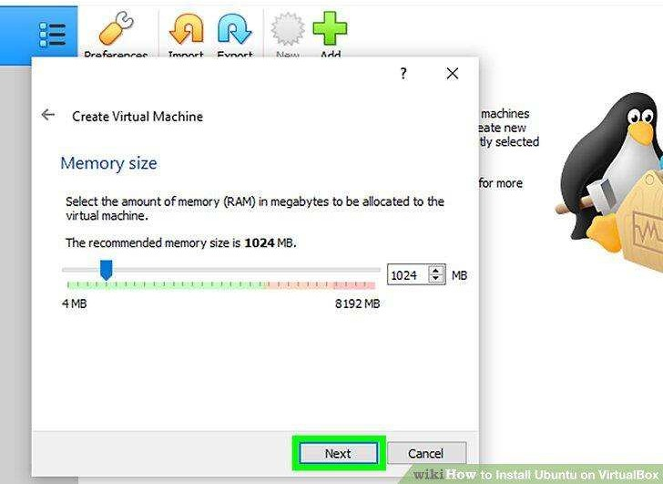

Click Next. It's at the bottom of the menu.

### 10.

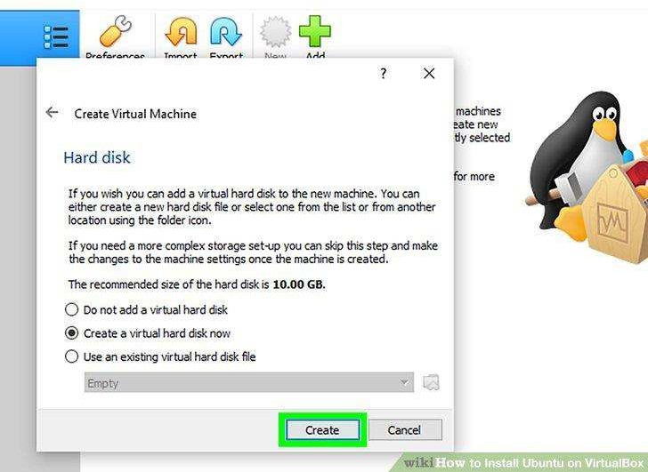

Create your virtual machine's virtual hard drive. The virtual hard drive is a section of your computer's hard drive space which will be used to store your virtual machine's files and programs:

# 11.

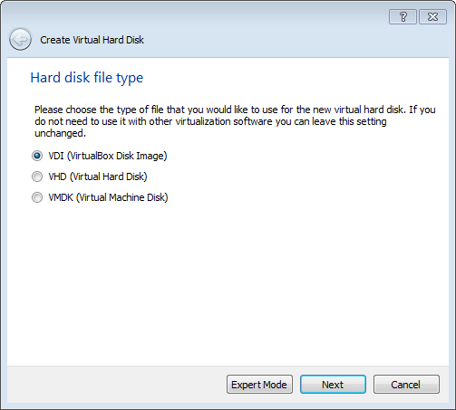

Use “VDI” to create a virtual hard disk

### 12.

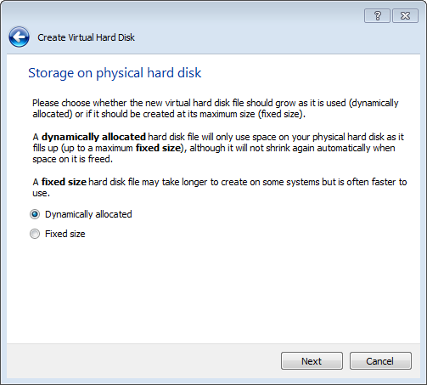

Choose “Dynamically allocated”.

### 13.

Allocate at Minimum 8 GB (recommended 10 or more).

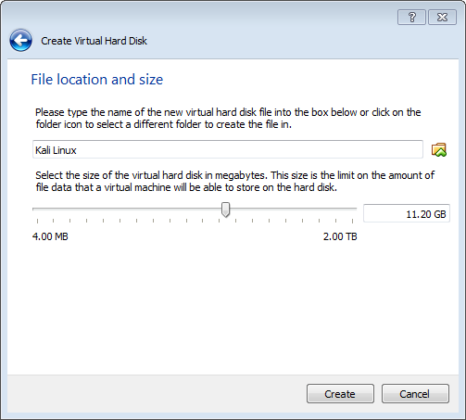

Click Create, to create your new virtual machine. The virtual machine is displayed in the list on the left side of the Virtual Box Manager window, with the name that you entered initially. VMs can run multiple operating system environments on a single physical computer, saving physical space, time and management costs.